**THE SPHINX AND THE GIZA PLATEAU’S PYRAMID COMPLEX’S MYSTERIES SOLVED**

**William John Meegan**

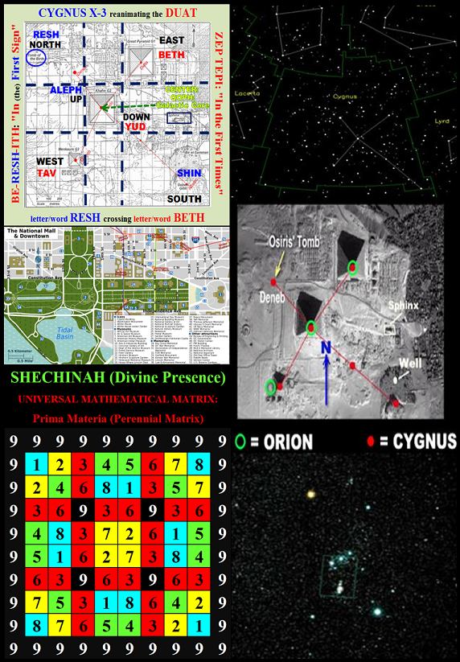

**ABSTRACT**

**T**

**he Sphinx and the Giza Plateau’s Pyramid Complex has had numerous unsolved mysteries for thousands of years. Both Robert Bauval (1994) and Andrew Collins (1999) put forth their individual theories on how to solve those mysteries; however, neither had any idea that it would take the unanimity of their theories to aid in explaining those ancient Egyptian mysteries.**

**To understand the unanimity of these theories there are two other major factors that have to be understood: the SHECHINAH (Divine Presence) (10²) and the TRINITARIAN PARADIGM: Trinity, to understand the esoteric dynamics of the Giza Plateau’s Pyramid Complex mysteries.**

**Four decades of esoteric and symbolic researches has given me a unique perspective of the SHECHINAH (Divine Presence) and the TRITARIAN PARADIGM: Trinity, in the world’s religions and mystery schools, which enabled me to tackle and solve these awesome mysteries.**

**The Sphinx is the key to solving these mysteries. When modernity first observed the Egyptian’s Sphinx it was just a skull lying on the sands of the desert. Life is lived between the ears. The Giza Plateau’s Pyramid Complex’s spiritual paradigm takes place between the ears.**

**Solving the Sphinx and Giza Plateau’s Pyramid Complex mysteries opens up all the mystical doors of esotericism and symbolism in all the major religions around the world.**

**INTRODUCTION**

**U**

**nderstanding the Sphinx’s and the Giza Plateau’s Pyramid Complex’s mysteries is just one of many ways that an initiate can learn about his or her Soul’s Two-Part Psyche: ego-consciousness and the unconscious mind. I say one of many ways; because, learning two or more ways, via literature, artworks and/or monuments from the same or other religions as to how the spiritual paradigm were developed in the outer world would bring clear and convincing evidence concerning the validity of religious mythological teachings around the world, which is in plain sight for every soul to envisage.**

**All major religions’ sacred literature, artworks and monuments mythoi and symbolism are based solely upon how the dynamics of the brain was structured: i.e. cerebral lobes. Astrology was actually created (numbered and named) to mirror-image the cerebral lobes of the brain in 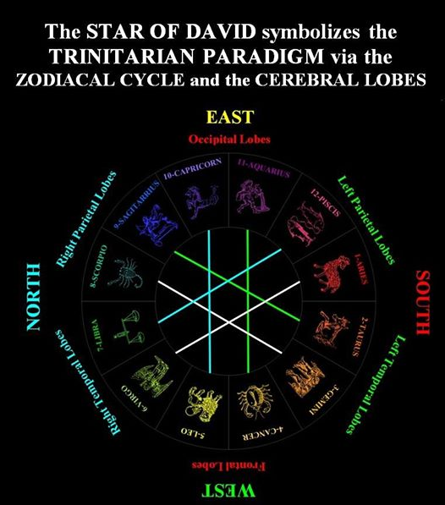order to aid the initiate in reading the mythoi of the world religious literature, artworks and monuments esoterically. From modernity standpoint this sounds absolutely ridiculous. The ancient maxim: KNOW THYSELF says it all; for the reason that, if the initiate does not know he or she live his or her entire life between the ears then it is a fruitless or an excruciating task for the initiate to study religion.**

**All religious literature, artworks and monuments are symbolic and mythological ways of explaining the dynamics of the cerebral lobes of the brain and how they deals with the spiritual forces radiating out of the pineal gland: i.e. Seat of God Merkabah or if you do not want to use the word God you can visualized those psychic forces as cymatic waves of the psyche or the tetrahedral forces of the psyche. Do not get caught up in semantics.**

**The spiritual paradigm that exudes from the pineal gland is what develops the ‘megalithic’ structure of the brain. In other words this spiritual paradigm transform Adam (humanity on an individual level) from his or her animalistic (childish) behavior to a decent human being not via morality, ethics or penal codes; rather, this spiritual process transforms the individual by elucidating him or her to the true spiritual nature of his or her psyche. I use the word ‘megalithic’ in relationship to the brain’s structure to emphasize how the cerebral lobes are permanent structural features in the brain, which cannot be altered. The entire universe is based solely upon the structure of the brain’s cerebral lobes.**

***The two hemispheres of the brain perfectly illustrates how the missive of the spiritual forces of creation: God (tetrahedral forces of the psyche) transubstantiate (bridging over) from the right side of the brain that’s develops abstract ideas to the left side of the brain that converts those abstractions into materialistic activities and when the transformation is complete it travel down the east-west-corridor-of-time (phantasmagoria of the psyche: the outer illusionary world): from the occipital lobes down to the frontal lobes. All ancient archaic religions are based solely upon this spiritual paradigm and this paper will illustrate how this is accomplished.***

**Catholicism’s laity will see this spiritual paradigm as the SIGN OF THE CROSS: North (Forehead) to South (heart) then West (Left shoulder) to East (Right shoulder). However, this latter statement is slightly off boundaries; because, the North is the Right shoulder and the East is the Forehead. This is why Christian cathedrals and churches are built in the shape of a CROSS mainly because the Northern Cross radiates it cosmic energy down to the earth saturating the sun with spiritual energy and this is why the Apse is in the East radiating out the Eucharist to the laity.**

**The spiritual paradigm of the psyche appears at first sight to be a complex system of thought; however, this spiritual paradigm is as simple as Catholicism’s SIGN OF THE CROSS: spirituality crossing (revitalizing) the materialistic raison d’etre (reason for living) in the psyche of a worthy initiate.**

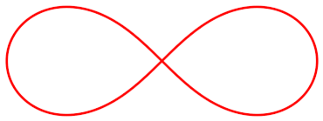**The SIGN OF THE CROSS is mystically shaped like the LEMNICATE, which is in the shape of the number eight (8) horizontally, which symbolizes infinite knowledge. Notice in the pattern of the SIGN OF THE CROSS the Eucharistic knowledge goes out West, then returns going towards the south Shoulder, then to the right (North) shoulder, then to the Apse in the East: Temple of God.**

**The SIGN OF THE CROSS takes place psychically in a mere nanosecond of time, which makes it a repetitive and perpetual activity in the brain. Those that do not use their brain to study religion or any of their activities in the world via detail analysis will not experience the 'Initiatic Visionary Experience.**

**The universe is set up like the cerebral lobes of the brain; for the reason that, life is lived between the ears. Initiates consciously build their sacred spaces: i.e. Cathedrals, Temples, Stupas, etc. in the outer world to mirror-image that spiritual psychic process: i.e. THE SIGN OF THE CROSS; nonetheless, all human activity is unconsciously and involuntarily exuding that same spiritual paradigm unto the blank abyss: outer materialistic realm via the SHECHINAH’s (Divine Presence) matrix.**

**The initiate that realizes he or she lives life between the ears has psychically worked him or herself completely free of Satan’s (ego-consciousness’) tyranny. Dante Alighieri in his La Divina Commedia has Satan at the bottom of Hell trapped half in and half out of an iceberg. That iceberg symbolizes the initiates biases, prejudices and preconceived notion that will not allow the iceberg per se to thaw.**

***That initiate has to realized that THE PHYSICAL OUTER WORLD DOES NOT EXIST, IT NEVER DID EXIST AND IT NEVER WILL EXIST; thus, freeing him or herself from the countless and idiotic dictates of societal mores’ belief systems, dogmas, and traditions; thus, such freedom, of independent thought, allows the initiate to think outside the box: so-to-speak.***

***I advise the reader to study each and every image, in this paper, studiously and in extreme detail. These images are not placed in this paper as pretty pictures; rather, they are place here to augment my commentary on this thesis. I will, throughout this paper, continuously reference the cover image above.***

***It is difficult for modernity to conceptualize that the bible via its indigenous languages are written with such scientific precision that it would take an initiate a lifetime of research to obtain an understanding of its basic spiritual paradigm. Reading and studying the bible iconoclastically (linearly – non-symbolic) is analogous to studying Celestial Mechanics; whereas, reading the bible outside of iconography is reading the bible esoterically: numerically and symbolically letter by letter, which is analogous to studying Quantum Mechanics. It’s done with an agonizing piercing analysis of just one word: An infinite amount of data is culled out of that word. It is like looking through the lenses of a microscope at an atom, which initially cannot be seen with the naked eye; yet, the analyst is going conceptually beyond the pale, beyond modernity intellectual comprehension.***

**Robert Bauval[1] and Andrew Collins[2]:**

**The Unification of their Researches**

**N**

**either Robert Bauval nor Andrew Collins was right or wrong in their theories. They were both right and wrong; but, not in the manner that most people would tend to think about.**

**Robert Bauval had no idea that he was dealing with the mythoi of the east-west-corridor-of-time. Everybody thinks that the Great Pyramid is in the NORTH; however, that is a slanted perspective in contexts to the entire layout of the Giza Plateau’s Pyramid Complex. The Great Pyramid is actually in the EAST with its right side facing NORTH; whereas, the smallest of the three great pyramids is in the WEST with it left side facing SOUTH.**

**Robert Bauval intuited idea that the Orion Constellation’s Belt correlated to the Giza Plateau’s three great (3) Pyramids, which actually symbolizes the east-west-corridor-of-time was a beautiful insight and it was an extremely important and intellectual contribution on how the world would forevermore look at the Giza Plateau’s Pyramid Complex; because, this latter statement symbolically aligns the three great Pyramids with a normal human belt and that is why I believe Robert Bauval envisaged the truth about Orion’s Belt.**

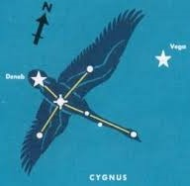**Andrew Collins’ work on the Giza Plateau’s Pyramid Complex with his investigative team researching the three great pyramids intuited that Cygnus X-3 (Northern Cross: Children of the Swan)[3] was an alternative theory as to what inspired the building of the three great pyramids.**

**Andrew Collin’s work cannot be said to be more important than Robert Bauval’s discovery; though, Andrew Collin’s thesis has more elements to it; because, without Robert Bauval insight the following thesis would not have been envisaged. In fact Cygnus X-3 would not have been considered an alternative theory to the Orion Constellation’s Belt if it was not for Robert Bauval’s inspirational work. Andrew Collins’ research on Cygnus X-3 was a worldwide project for him. Andrew Collins went all over the world exploring the mythoi of indigenous cultures and major religions and he found that they all reverence a bird that symbolized Cygnus X-3, which is in the north along the rift of the Milky Way Galaxy.**

**I agree that the Giza Plateau’s Pyramid Complex: Orion Constellation’s Belt and Cygnus X-3 are analogous to the mystery of the Chicken and the Egg. Which came first, the chicken or the egg? Which came first the Giza Plateau’s Pyramid Complex’s earth-sky interface with the Orion Constellation or the earth-sky interface with the Cygnus X-3 Constellation?**

**I, personally, interpret that the Giza Plateau’s Pyramid Complex was developed by the ancient Egyptians with both theme simultaneously in mind; nonetheless, I tend to believe that mystically the Orion Constellation emanates out first; because, it symbolizes the childish thinking of people that know nothing about spirituality; whereas, Cygnus X 3: Children of the Swan is pattern in the precise manner as spirituality that blankets out the Orion Constellation Belt, symbolized by the three great Pyramids, on the Giza Plateau, via the pattern of the Northern Cross.**

**The Northern Cross (spiritual thoughts) obviously overshadows the Orion Constellation Belt (materialistic thinking) by taking the Orion Constellation Belt: materialistic thought patterns, into its own spiritual thoughts via Active Imagination in continuously creating creation within the Vesica Piscis: CHRIST’S Merkabah.**

**The SHECHINAH (Divine Presence) and**

**The TRINITARIAN PARADIGM**

**T**

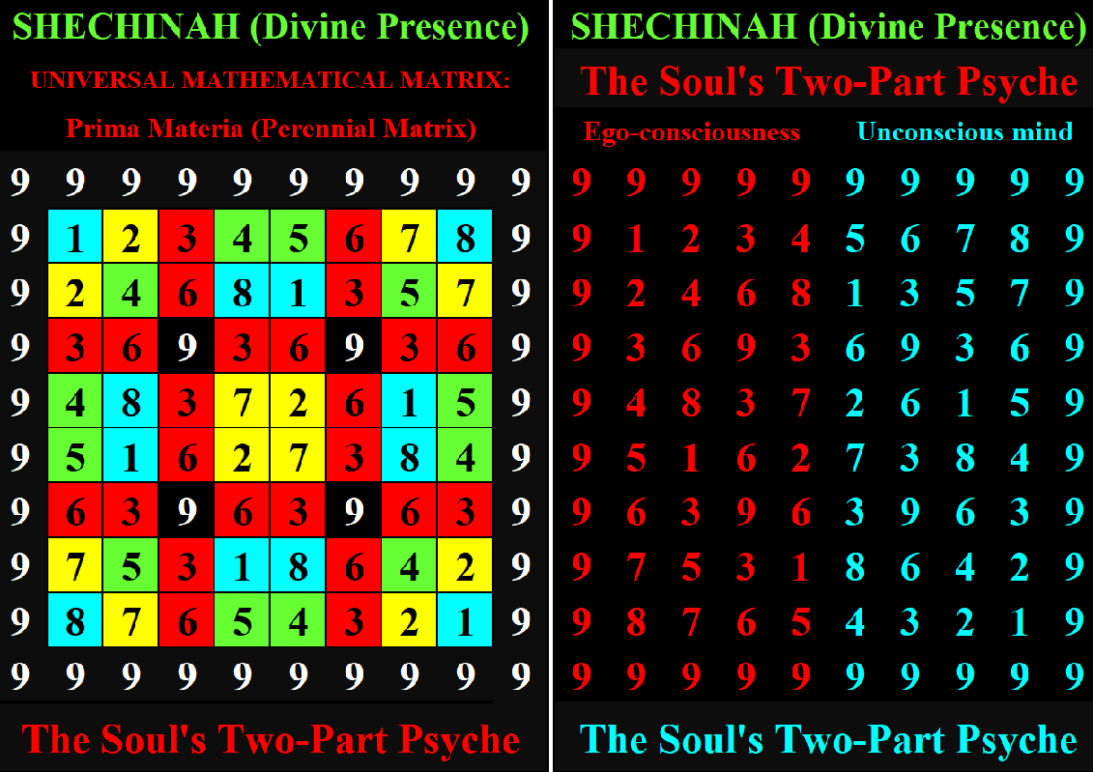**here are two major themes: the SHECHINAH’S (Divine Presence) (10²) matrix and the TRINITARIAN PARADIGM that are not discussed by academics, Egyptologists, or independent researchers that write about the ancient Egyptian culture, which is most likely because they know absolutely nothing about them otherwise I would not be writing this paper unifying Robert Bauval’s and Andrew Collins’ researches.**

**Robert Bauval had an interview on a YOUTUBE video: BEYOND THE ORION CORRELATION[4] and his greatest concern was about the people that built the Giza Plateau’s Pyramid Complex and why they built it. These two above mentioned themes and more will answer Robert Bauval’s concerns.**

**The SHECHINAH’S (Divine Presence) matrix is an esoteric (hidden symbolic missive) commentary on the MONAD, which psychically represents the SOUL via its Two-Part Psyche: ego-consciousness and the unconscious mind. The soul per se does not comes into the material plane of existence; however, it splits into its Two-Parts Psyche literally radiating out the spiritual paradigm that is laid out in all religions around the world. The SHECHINAH’S (Divine Presence) matrix symbolizes the entire psyche (universe) releases ego-consciousness (sun) down the east-west-corridor-of-time. Per se ego-consciousness does not exist; for the reason that, it is rebirthed every nanosecond of time; though, what makes ego-consciousness appear to be a permanent fixture in the psyche is the personal unconscious (memory database) and it is this that creates the psyche’s raison d’etre: i.e. addictions and/or obsessions, which creates the character and personality of the individual.**

**THE SHECHINAH’S (Divine Presence) Matrix**

**T**

**he first theme is all about the SHECHINAH’S (Divine Presence) matrix, which is known all over the world by every indigenous culture’s major religion and mystery school. China developed the I Ching, Tao te Ching, its culture’s clothing and buildings based upon the SHECHINAH’S (Divine Presence) matrix design, Buddhism creates their Stupas from it, Hinduism and Christianity build their temples and churches based upon its schematics. The pyramids of the world are build upon its design. Both the Game of Chess and Astrology were developed from it and the city of Washington DC (USA) is built upon the SHECHINAH’S (Divine Presence) matrix. Washington DC’s National Mall is also design after it spiritual theme as if it was created as a mini-version of the matrix to symbolize the Temple of Democracy. The SHECHINAH’S (Divine Presence) matrix is an actual symbolic image (sacred geometry) representing the human psyche and from it all creation, both spiritual and material, commences. The SHECHINAH’S (Divine Presence) matrix is psychically hidden from the infidel and the profane: i.e. uninitiated; for the reason that, the uninitiated knows nothing about the unconscious mind and neither has the mental acuity to envisage the matrix nor do they have the attention span of a gnat. Most people unknowingly suffer Attention Deficit Hypoactive Disorder (ADHD).**

**The SHECHINAH’S (Divine Presence) matrix is never-ever discussed openly to the laity; because, it is the initiate’s personal responsibility to envisage the matrix on his or her own volition even though he or she does not know of the SHECHINAH’S (Divine Presence) matrix existence; yet, it is the essential platform that the soul’s Two-Part Psyche lives out its life in the phantasmagoria of the psyche, which is symbolically the same platform that the Giza Plateau’s Pyramid Complex sits upon.**

**There is a great deal more to this SHECHINAH (Divine Presence) matrix than what I will discuss in this paper. This SHECHINAH (Divine Presence) creates the outer universe by psychically projecting itself: i.e. the soul’s two-part psyche: ego-consciousness and the unconscious mind outwardly upon the blank abyss. The SHECHINAH (Divine Presence) writes the sacred scriptures of the world esoterically (hidden). The greatest mystery concerning esotericism is that; though, I am writing this paper to put the TRUTH out there; nonetheless, realistically all that I am doing is educating my own psyche about the dynamics of my soul. Nobody can truly teach any other soul about itself; for the reason that, each soul has it own experiences building up a reservoir of personal biases, prejudices and preconceived notions: personal memory database that will be psychic barriers battling the TRUTH, which cannot be traversed by anybody else.**

**It is no coincidence that the Giza Plateau sit upon the center of the world’s land mass; for the reason that, every single individual’s psyche is based solely upon the SHECHINAH’S (Divine Presence) matrix; therefore, the phantasmagoria of the psyche is projected outward upon the blank abyss of the psyche and the universe is known as the outer world. If the reader wants to know what the blank abyss is all about just close your eyes and/or speak to a blind person about the darkness of his or her life. All of life is lived between the ears not outside of the skull: THE PHYSICAL OUTER WORLD DOES NOT EXIST, IT NEVER DID EXIST AND IT NEVER WILL EXIST.**

**Everything that a human being does: i.e. thought, word or deed is done is in the image and likeness of the SHECHINAH’S (Divine Presence) matrix; though, that sound inane and seem to be a very ridiculous statement to make, it nonetheless is true and TRUTH is what it is.**

**The SHECHINAH’S (Divine Presence) matrix symbolism and overall pattern, for the most part, coincides with Andrew Collins’ work on Cygnus X-3 and I will be discussing this matrix much more as this paper unfolds.**

**The TRINITARIAN PARADIGM: Trinity**

**T**

**he second theme that is rarely discussed about the ancient Egyptian culture is the Trinitarian Paradigm: Trinity. This second theme corresponds more with Robert Bauval’s work. I call this second theme the Trinitarian Paradigm: Trinity; for the reason that too many diverse symbolic patterns in the world mirror-images the Trinitarian Paradigm’s pivitol three-part pattern; thus, the Trinitarian Paradigm is not monopolized by just the symbols of the Trinity’s threefold deities per se; though, the whole world is monopolized via thought, word and deed by the Triune God. What is meant by this is that if the Triune God is ever discussed in any religion it is done in context to the three personalities of the one God: Father, Son and Holy Spirit; however, what is not generally known is that all of creation seen (ego-consciousness) and the unseen (unconscious mind and mainly Christ consciousness) symbolizes the Soul’s Two-Part Psyche. The outer world generically is the SHECHINAH’S (Divine Presence) matrix that all souls live on it, which is analogous to the ancient Arabian’s Alladin’s Carpet; however, within that matrix each soul individually creates his own personal conscious identification bubble so-to-speak: i.e. his or her sacred space.**

***I advise the reader to view the two episodes of STAR TREK VOYAGER: Season 6: episode 26: Unimatrix Zero (Part 1)[5] and Season 7: episode 1: Unimatrix Zero (Part 2)[6]. This will conceptually give the initiate an idea of how the soul can remain outside the time/space continuum; yet, still live in the phantasmagoria of the psyche. There is also the movies series the MATRIX TRILOGY[7] that the initiate is advised to view; because, it additionally will add credence to the initiate living in the psyche while the body lives in the world. These episodes of Star Trek Voyager and the Matrix Trilogy will give the reader an idea of how life is lived between the ears.***

**The entire Giza Plateau’s Pyramid Complex is based upon the pivotal themes of the SHECHINAH’S (Divine Presence) matrix and the Trinitarian Paradigm. Most people look at just the three great pyramids and how they coincide with the Orion Constellation’s Belt, when in actuality, the Giza Plateau’s Pyramid Complex was built to mirror-image the Trinitarian Paradigm that the human psyche was already mirror-imaging on the earth. Building the Giza Plateau’s Pyramid Complex is, obvious at least to me, a representation of the Orion Constellation interface with the dynamics of the human psyche’s activities in the outer world: i.e. sky-earth interface. How I know this latter hypothesis is true for the reason that, Michelangelo went into the Sistine Chapel to fresco a commentary on the ceilng based solely upon the mosaic in the floor, the frescoes on the walls: i.e. Life of Jesus Christ and the Life of Moses and the 32-popes frescoed midway up the walls between the floor and the ceiling; thus, Michaelangel (Michael the Archangel) did a sky-earth interface, which is analogous to what was done on the Giza Plateau’s Pyramid Complex in relationship to the Orion Constellation’s Belt and Cygnus X-3 (Northern Cross: Children of the Swan).**

**The Giza Plateau’s Pyramid Complex is of course not the only monument that is based upon the schematics of the SHECHINAH’S (Divine Presence) matrix and the TRINITARIAN PARADIGM as I listed a number of major religions above that utilizes these two theme symbolically; additionally, these two themes are artistically expressed in Chartres Cathedral in the precise manner that the Giza Plateau’s Pyramid Complex is laid out. I just wrote a recent paper on: EZEKIEL’S MERKABAH IN CHARTRES CATHEDRAL[8] illustrating these two themes worked into the symbolism of the stain glass windows and this same psychic pattern of the cerebral lobes is laidout in the frescoes of the Sistine Chapel and then of course there is Freemasonry’s layout of Washington DC National Mall. Recently I wrote a book: God’s Ambiance[9], which explain a great deal about what the SHECHINAH’S (Divine Presence) matrix is all about.**

**If the Giza Plateau’s Pyramid Complex was the only site is the religious world depicting the unanimity of both these themes it would be superfluous to write about it; however, all the world’s religions are based upon both these same two themes that symbolize the dynamics of the psyche. All religions around the world in all times and climes parallel each other using different mythoi to express the spiritual forces in creation: i.e. WORD OF GOD.**

**The complexity of reading symbolism in religious literature and/or artworks and/or monuments is that the whole spiritual paradigm is laid out to perfection from beginning to end. There is no evolutionary process of learning the mystical nature of esotericism from beginning to end. The authors, artists and architects that wrote, created and structured their esoteric understanding of the WORD OF GOD knowing the full dynamics of the psyche and how the SHECHINAH’S (Divine Presence) matrix and the TRINITARIAN PARADIGM needed not infidels and profane to understand their works. The ancient sages’ works were not meant for the infidel and profane. Only initiates that were in the know could read it; thus, on entering the sacred scriptures, a cathedral or museau of religious artworks the whole science of the WORD OF GOD is complete.**

**Humans are use to learning by studying topics chronologically via iconoclasm; however, religious teaching can only be understood by contemplatively breaking the symbolic literature, artworks and monuments down piecemeal via extreme detail analysis and conceptually putting it all back together. This is very much what a child does with his or her toys; whereas, adults try to envisage thought by scanning the surface area of what they are studying. The child does what he or she instinctually sees as how to obtain knowledge; whereas, an adult has been trained in the strict disciplinary rules and regulations of societal mores; thus, this is why the average citizen does not breach the barriers of societal mores.**

**THE THREE GREAT PYRAMIDS CORRELATING**

**TO THE GREAT PYRAMID’S THREE CHAMBERS**

**N**

**obody has yet put forth the hypothesis that the three chambers of the Great Pyramid also coincide with the Trinitarian Paradigm that the psyche and the Orion Constellation’s Belt projects. It is because of the symbolism of the Orion Constellation’s Belt that the three chambers are in the Great Pyramid.**

**The King’s and Queen’s Chambers inside the Great Pyramid coincides with the symbolism of the Great Pyramid and Khafra’s Pyramid respectively.**

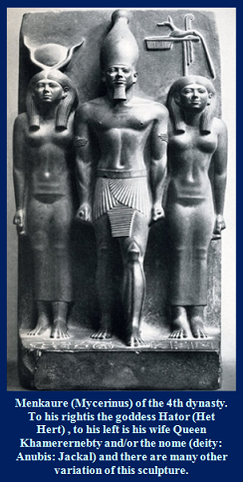**Hator (Queen Chamber in the Great Pyramid) symbolizes Khafra’s Pyramid; for the reason that, it is the CROSSING in the east-west-corridor-of-time (Orion Constellation’s Belt) and the CROSSING in the north-south flight of the Cygnus’ Swan. The CROSSING from north to south literally creates a CROSS on the Giza Plateau’s Pyramid Complex landscape: hence the naming of Cygnus X-3 the Northern Cross and/or the Children of the Swan.**

**Queen Khamerernebty (Subterranean Chamber in the Great Pyramid) symbolizes the Menkaure Pyramid (smallest of the three pyramids); because, it is off alignment to the other two pyramids, which is why Menkaure Pyramid symbolizes the Subterranean Chamber in the Great Pyramid. Menkaure’s Pyramid symbolizes chaos; for the reason that, it is off alignment to the Khufu and Khafra pyramids and this is why the Subterranean Chamber is unfinished and basically its measurement are considered in a total disarray.**

**The image to the right is Pharaoh Menkaure with two goddesses flanking him. This is a great image illustrating the Trinitarian Paradigm; because, it illustrates how Pharaoh Menkaure is guided by the two goddesses. Hator has her left arm wrapped around Pharaoh Menkaure and Queen Khamerernebty has her right arm wrapped around him. This places Pharaoh Menkaure is a very rigid position. Both female goddesses are in the background. Hator has her left foot sightly put foreward as if she symbolizes Pharaoh Menkaure being guided while he is alive; whereas, Queen Khamerernebty has both feet rigided placed as if without movement guiding Pharaoh Menkaure while he is in the land of the dead.**

**Hator is the Goddess of the Moon[10] symbolizing both the Sun (material) and the Moon (spiritual); for the reason that, her headdress symbolizes the horns of the cow (Moon) holding the orb of the Sun. This also symbolizes the union of the upper and lower regions of Egypt, which symbolizes the birth of Horus-consciousness.**

**Queen Khamerernbty symbolizes the world of the dead; because, Anubis is above her head. Queen Khamerernbty symbolizes the death of Horus-consciousness and the birth of ego-consciousness: the Jackal/trickster.**

**However, notice that Pharaoh Menkaure is first in line and the goddess Hator is second in line; because, her left foot is slightly foreward and Khamerernbty is last in line; because, her feet are motionless. This alignment solidify which of the three great pyramids is asign to them.**

**It is extremely interesting that ancient Egypt has all these Trinitarian Paradigm symbolic images symbolizing the Orion Constellation’s Belt, which sybolizes the three great pyramids, which in turn symbolizes the three chambers in the great pyramid, which in turn symbolizes the sculpture of the Pharaoh Menkaure and the two goddesses flanking him also corresponding to the alignment of the three Great pyramids? That per se cannot be a coincidence.**

**THE GREAT PYRAMID’S STAR SHAFTS**

**T**

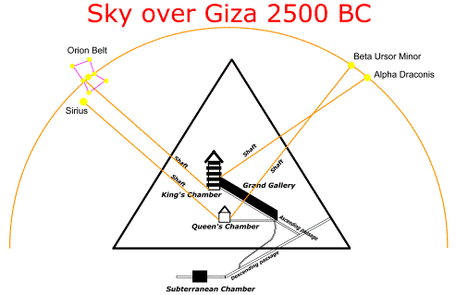**he King’s Chambers star shafts are aligned to the Orion Belt Constellation and and Alpa Draconis Constellation; however, the Giza Plateau’s Pyramid Complex is designed inside of the SHICHINAH’S (Divine Presence) matrix, which aligns those star shafts to the Tomb of Osiris and the Well of Souls in the Islamic Cemetery in Gebel Ghibli. The Draco constellation symbolizes El Hanash: the serpent, which is still believed, spiritually, in modern times to be in the tunnels system beneath the Giza Plateau’s Pyramid Complex.**

**Whereas, the Queen’s Chamber is an altogether different matter when its star shafts are aligned to star constellations. When the Queen Chambers is fully spiritually understood there really is no star system other than itself for it to point to. When the Queen’s Chamber was first viewed by ancient and modern people it so-called star shafts were not seen they were walled off. The inference is that the Queen’s Chamber symbolizes a selfcontained enviroment. There is no place for the spiritualized soul to go; because, its milieu symbolizes eternal life. Below I will discuss how the Giza Plateau symbolizes a spherical symbol and the Queen’s Chamber would symbolize Krafre Pyramids, which would symbolize three directions: up, center and down.**

**When the Queen’s Chamber’s star shafts were discovered they pointed to The Sirius Constellation and Beta Ursor Minor Constellation. These stars system could be seen when the Queen’s Chamber lost her spiritual sheen so-to-speak and ego-consciousness rather that Horus consciousness reigns supreme in the pysche. I hypothesize that symbolically the Queen’s Chamber symbolizes Krafre’s Pyramid that symbolizes the pineal gland: glactic core.**

**CYGNUS X-3: The Northern Cross/**

**Children of the Swan**

**A**

**ndrew Collins’ theory via his images of the Giza Plateau’s Pyramid Complex are incorporated into the title and cover image of this paper. Andrew signified the Orion Constellation’s Belt with green circles and his image’s red dots symbolizes Cygnus X-3. That image alone should have inspired him to see that there was an correlation between the Orion Constellation’s Belt and the constellation of Cygnus X-3; however, that image was initially created to illustrate that Cygnus X-3 corresponded to the Giza Plateau’s Pyramid Complex more perfectly than the Orion Constellation.**

**What confused me for the longest time after reading Andrew Collins’ work on Cygnus X-3 and the Bird Caves that he discovered was why he did not have Collins’ Bird Caves: *EL-KAHF EL-HANASH* (The Cave of the Snake) as a designate for the star Deneb. It turned out that Andrew, himself, provided the answer. He chosed the Tomb of Osiris for the star Deneb. After seeing that I began to purchase a lot of books on Osiris; though, I already knew the rudimentary story about this Ancient Egyptian God and the internet provided a good deal of information about Osiris’ mythology; though, I did not quite understand why a fake tomb would solve the problem. This Osiris Tomb was built to honor Osiris. The Tomb of Osiris reminded me of the Church of the Holy Sepulchre in Jerusalem where Christ’s grave is honored. The mythoi of Christ are in some ways mirror-imaging the mythoi of Osiris; however, I see Christ’s ministry as reanimating the Duat: Orion Constellation; whereas, Osiris (initiate) symbolizes Taurus the Bull: i.e. ego-consciousness is crucified on the Giza Plateau’s Pyramid Complex; whereas, the Soul: i.e. Christ symbolized by the Holy Spirit: i.e. Cygnus Swan dies the moment it enters the material creation, which explains why there is the Tomb of the Birds; however, realistically and symbolically Christ (Horus) consciousness is reborn every nanosecond of time.**

**Christ (Cygnus X-3) in reanimating the Orion Constellation: Osiris (initiate); for the reason that, Aries is the FIRST SIGN (April First is Christ’s conception date): i.e. sacrificial lamb (Ram in the Akedah) and this is the reason why the Cygnus Swan dies before it enters materialistic reality; whereas, Taurus the Bull is considered the Duat: Orion Constellation, which is called Zep Tepi: i.e. First Times in the material world via the three great pyramids. There is diametrically a difference between the Zodiacal signs: HEAVEN and the corporeal Calendar Times Cycles: EARTH. In fact it is these two diametrically different cycles that are Ezekiel’s Merkabah wheels in the skull that animates the tetrahedral forces of the psyche.**

**Those that read the book of Genesis may have envisage this Taurus phenomenon; because, every second son (or beyond if necessary) inherits the family’s estate; because, the first son is dedicated to God. This is the reason why the second Hebraic letter: BETH בּ is the first letter of Genesis.**

**Some time ago in communicating with Andrew Collins I had a passing debate over what the snake symbolized. The Arabic wording “*El Hanash*” seems, to me, to be interpreted as the “the Serpent God (Kundalini Serpent)” and the reason I interpreted it in that way is because in Hebrew the word “EL” is interpreted as God, which is also the New Testament God; whereas, Andrew only saw that word meaning “THE”. This is often done when translators do not know the meaning of Hebraic letters and do not comprehend the contexts a word is used in the texts of the sacred scriptures. At the time I had to acquiesce to Andrew’s opinion; because, I did not have enough evidence to back up my inspirational thoughts about the serpent mystically in the Bird Caves; because, the word “EL” was after all written in Arabic. I was also at that time thinking in context to the Pharaoh having the serpent coming out of his forehead indicating that the serpent was the pivotal guide coming out of the center of two hemispheres of the brain leading the Pharaoh down the east-west-corridor-of-time. Images of the Kundalini Serpent are mystically ethereal; because, the spiritual serpent truly cannot be 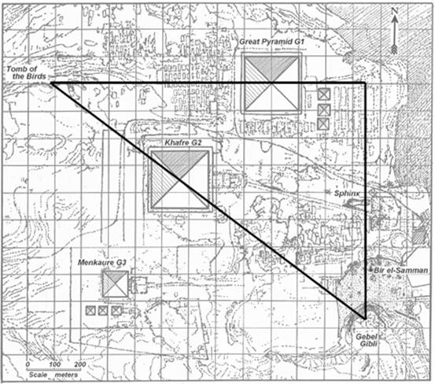envisaged with the naked eye; thus, El Hanash is not a psychical serpent; thus, that is another reason it cannot be ‘THE SERPENT’. I will talk more about the serpent later.**

**Andrew Collins’ friend and research partner Rodney Hale[11] discovered the 3:4:5 Pythagorean Triangle on the Giza Plateau’s Pyramid Complex. This was one of the major issues that confused me about Cygnus X-3 not aligning to the Collins Bird Caves; however, the Pythagorean Triangle certainly does emphasize the Collins’ Bird Caves as having an overall importance to the Giza Plateau’s Pyramid Complex construction.**

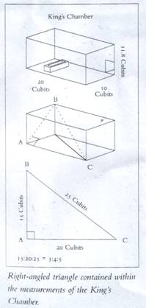**What is intriguing about Rodney Hale’s discovery of the 3:4:5 Pythagorean Triangle is that the King’s Chamber in the Great Pyramid also reflects the 3:4:5 Pythagorean Triangle. This latter description of the 3:4:5 Pythagorean Triangle is laid out in Graham Hancock’s and Santha Faiia work: HEAVEN’S MIRROR: Quest for the Lost Civilization (page #53)[12]. The image below on the next page comes off of Graham Hancock’s website, which published Nicholas Kollerstrom’s article GEOMETRY OF THE GREAT PYRAMID[13] and Nicholas got permission from Graham and Santha to publish this image.**

**Think about the Pythagorean Triangle in the Great Pyramid when it has already been illustrated that the Trinitarian Paradigm also is illustrated in its premises via its three chambers symbolizing the three pyramids. Graham and Santha show the following calculation on the same page of this image:**

* **PYTHAGOREAN PARADIGM:**
  + **3 x 3 x 3 = 27**
  + **4 x 4 x 4 = 64**
  + **5 x 5 x 5 = 125**
  + ***“Then we get the total of 27 plus 64 plus 125 is the processional number 216.”* Graham and Santha were referencing 216 = 2160-years representing one equinoctial sign.**

**I totally agree with this analysis especially since the Giza Plateau’s Pyramid Complex is all about Cygnus X-3, which literally symbolically is referencing the First Sign and simultaneously symbolizes releasing the sun: 216 is the cube of 6³; whereas, 6² (6 x 6 = 36) is the Kamea (Magic Square) of the Sun.**

**Also note the King’s Chamber has exactly one-hundred blocks, which is symbolic of the SHICHINAH’S (Divine Presence) matrix (10²).**

**The point being made here is that all of these symbolic images are laid out on the Giza Plateau’s Pyramid Complex and these symbolic images are also incorporated symbolically into the Great Pyramid, which symbolizes the King’s Chamber as if it begins the process of spiritually going down the east-west-corridor-of-time. It is as if redundancy is put into place as the hall mark of science; but, also to validate their presents.**

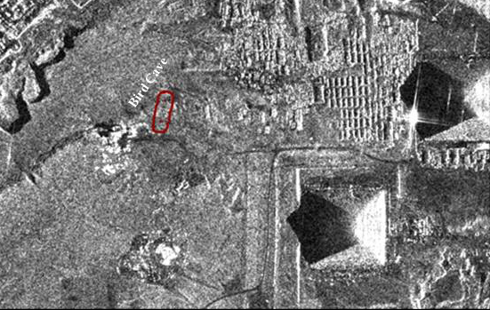**Nigel Skinner Simpson another friend and research companion of Andrew Collins located the Bird Caves by researching ancient archeological memoirs written by British diplomat and explorer Henry Salt, which hails back to 1817, from out of the British museaum which was just recently published. If it was not for Nigel Skinner Simpson excruciating detail analysis of a map of the Giza Plateau’s Pyramid Complex the Bird Caves would never have been discovered in these modern times. Knowing academia and Egyptology it would have taken at the very least another century to discover the Bird Caves; but, being discovered at a later date the Bird Caves would have had to be put into context to the whole of the Giza Plateau’s Pyramid Complex. It is quite remarkable that Andrew’s Collins research team, which included Andrew’s wife, Sue Collins discovered the location of the Bird Caves. It is as if Andrew Collins’ research team was destine to do so; because, of Andrew’s years of research on the Cygnus X-3 Mystery.**

**The layout of Cygnus X-3 on the Giza Plateau’s Pyramid Complex has the head of the Swan in Gebel Ghibli where the Well of Souls (Islamic Cemetary) is located and the tail of the Swan positioned over the Tomb of Osiris. The wings of the Swan span out to the Great Pyramid and Menkaure Pyrmid and the Swan’s breast: heart’s raison d’etre covers the Khafre Pyramid. What is interesting here is that there are no corpses found in any of these pyramids; for the reason that, the spiritual grave site is the Bird Caves and what appears to be physical graves are in the Islamic Cemetary; however, this Islamic Cemetary is not symbolically considered an earth grave; because, it is called the WELL OF SOULS. Remember that the Garden of Eden symbolizes life eternal. The spiritual sun traveling down the east-west-corredor-of-time symbolizes the Kundalini Serpent: i.e. the initiate walking with God in the Garden of Eden. It would not be possible to have a dead human body in anyone of those pyramids with that spiritual paradigm being conveyed.**

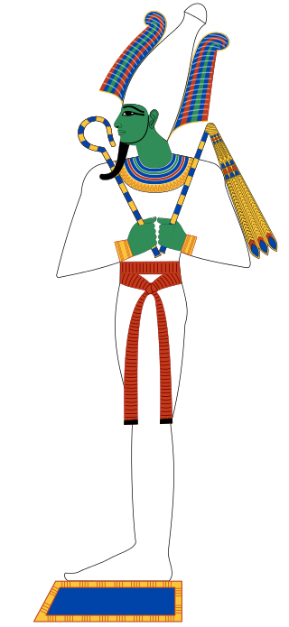**Those two graves sites flanking the three great pyramids: the Bird Caves and the Well of Souls are not symbolizing physical death; rather, the BIRD CAVES symbolize the spiritualized initiate vanishing from ego-consciousness into Horus (Christ) consciousness walking with God in the Garden of Eden; whereas, the WELL OF SOUL symbolized Hell on Earth, where the infidel and profane walk around like zombies: i.e. living dead tormented by Satan: i.e. ego-consciousness. Per se there is no such thing as the death of the soul (total absolute annihilation). When religion talks about death in its mythoi it is referring to the initiate turning his or her back on materialism or the initiate returning to gorging on materialism. These are the only two forms of that can be conceptualized as death. What humanity calls death is merely the human body: *the living rotting-aging corpse* no longer being animated by the spiritual forces of creation. If the initiate sits back and thinks about it only the body ages. The psyche stays eternally young. The body exists in the time/space continuum; whereas, the soul exist in timelessness otherwise the psyche would age parallel to the aging of the body and that kind of life would be catastrophic.**

**THE TOMB OF OSIRIS**

**O**

**n the first page is an image of the Giza Plateau illustrating where Osiris’ tomb is located. Thus, Osiris’s tomb is located just before the Bird Cave, which suggests that Osiris was seeking to be flown to outer space. Every Egyptian that dies is called Osiris.**

**The Tomb of Osiris represents the star of Deneb in the Cygnus X-3 constellation, which is the tail end of the swan. Tomb of Osiris is not a real tomb it was created to give honor to Osiris just as the Tomb of the Sepulcher in Jerusalem was build to worship Christ. Christ’s teachings symbolize the silence WORD OF GOD. What is meant by Christ becoming flesh is that when the spiritual forces of creation comes into the world and transubstantiated over from the right side of the brain to the left side of the brain those spiritual forces have been understood conceptually. That body of thought is per se the body and blood of Christ.**

**Osiris was the ruling Egyptian God. In the first chapter of Genesis the word ELOHYM is interpreted as ‘GOD’. When the word ELOHYM is broken up into its constituent components via Gematria it radiates out the formula for PI: 3.1415 and when cubed it totals to thirty-one (31), which is the amount of verses to the first chapter of Genesis. There are four-hundred and thirty-four (434) words in the first chapter of Genesis and when divided by thirty-one (31) the quotient is fourteen (14). Osiris’ body was cut up into fourteen parts. The missing phallus prevented Isis (unconscious mind) from having Horus consciousness. The missing phallus is symbolized by the obelisk, which in turn symbolizes the cosmic rays coming from the Cygnus X-3 constellation. The pineal gland symbolizes that phallus, which is often seen throughout the world as symbolizing the central fountain of a city giving the population the water of life.**

**The soul symbolically comes into the world via its Two Part Psyche: ego-consciousness and the unconscious mind. The soul is symbolized as an angel: i.e. the Cygnus Swan, which releases the spiritual sun (fallen angel) into the world, which is known as the rising sun that sets (dies) in the west.**

**Osiris (Christ, Horus, Krishna, Buddha, Tao, etc.) is initially that spiritual Sun released into the world and is eventually assassinated by his brother Seth: i.e. ego-consciousness. In this paper’s cover image the Tomb of Osiris is positioned in a number two (2) cell in the SHICHINAH’S (Divine Presence) matrix and Menkaure’s Pyramid sit in a number seven (7) cell. In the first chapter of Genesis the word LIGHT has the Gematria value of two-hundred and seven (207) and this is why there are twenty-seven (27) books in the New Testament. The Old Testament has 925 chapters minus one (last chapter of Zachariah is the pivotal chapter of the bible: read this last chapter about Mount Olive) and the New Testament has 260 + 4 (Book of Malachi that speaks of Elijah: John the Baptist): 924 / 264 = 3½: i.e. Kundalini Serpent: 7 / 2 = 3½. Just as Christ symbolizes the Kundalini Serpent (El Hanash) so does Osiris. The ninth Hebraic letter of the Hebrew Alphabet is TAYT ט that symbolizes the (serpent).**

**THE GIZA PLATEAU’S PYRAMID COMPLEX**

**IS A SPHERICAL BUBBLE AND IT AND OTHER SPIRITUAL**

**CONCEPTS ALREADY DISCUSSED CAN BE ILLUSTRATED**

**VIA THE SYMBOLISM OF THE JUDAEO CHRISTIAN MYTHOI**

**A**

**s much as I do not want to I have to discuss this spiritual paradigm: SHICHINAH’S (Divine Presence) matrix and the TRINITARIAN PARADIGM’S layout on the Giza Plateau’s Pyramid Complex via the Judaeo Christian mythoi to validate the concepts I am discussing in this paper. After these analogies are discussed I will be discussing the mysteries of the Sphinx psychic relationship to the Giza Plateau’s Pyramid Complex.**

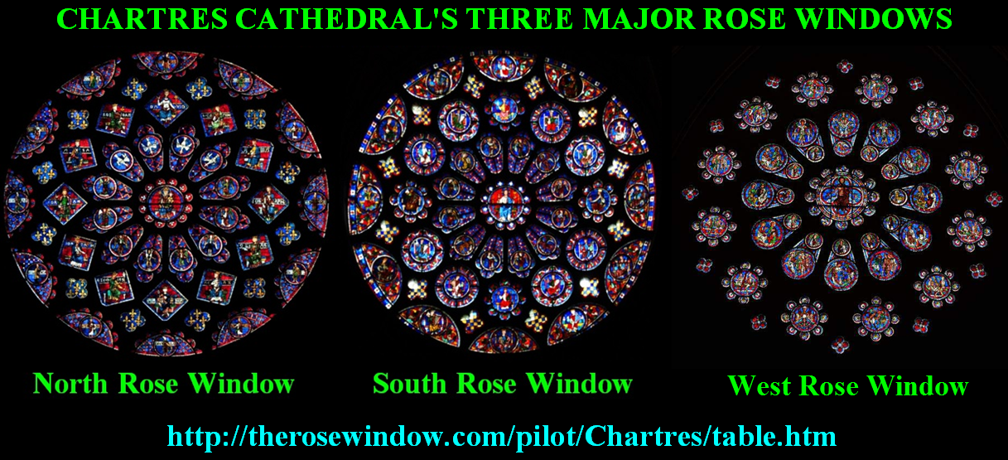**Below I place an image of the three Rose Windows of Chartres Cathedral to illustrate that the pattern of the two graves sites flanking the Giza Plateau’s Pyramid Complex is universal. In Chartres Cathedral the North and South Rose Windows flank the CROSSING in the transept between the Apse and the Nave. Geometrically these three Rose Windows form a gigantic triangle analogous to a pyramid. Going from the Apse down the Nave is symbolically going down the east-west-corridor-of-time.**

**There is only one transept; however, every single stain glass window on the north side of Chartres Cathedral symbolically crosses the Apse and/or Nave symbolizing past ethereal transepts. There is only one transept in Chartres Cathedral; for the reason that, there can only be one at any given nanosecond of time. This is why there is only one set of three great pyramids on the Giza Plateau’s Pyramid Complex. The stain glass windows on the north side of Chartres Cathedral prior to the present transept are future transepts and the stain glass windows on the north side going west from of the present transept are past transepts.**

**This suggests the never-ending spiritual process of God radiating Himself into the soul’s abode. This is an extremely important spiritual concept that is embedded into the first word of Genesis: BERESHITH בּראשית. In the Prologue of the Zohar it talks about the Hebraic Alphabet coming before the Lord of the World letter by letter: i.e. Yahweh, which is symbolized by the Hebraic letter YUD י: i.e. ego-consciousness (cerebral lobes on the left side of the brain). All of this is envisaged in the first word of Genesis: BERESHITH בּראשית. According to the Zohar the Hebraic letter YUD י symbolizes Yahweh and the letter ALEPH א symbolizes Elohym. YUD י is positioned in the center of the Hebraic letter/word: BETH בּ: Beth בּ,Yud בּ, Tav ת of the Torah; whereas, ALEPH א symbolizes Elohym: i.e. unconscious mind (cerebral lobes on the right side of the brain). ALEPH א is positioned in the center of the Hebraic letter/word: RESH ר: Resh ר, Aleph א, Shin ש. When these two Hebraic letters: BETH בּ and RESH ר merge they form the first word of Genesis: BERESHITH בּר. When these two letters BETH בּ and RESH ר merge they mystically form Christ consciousness, which is symbolized by the Hebraic letter QOPH ק, which is the last letter in the spelling of the word CHRIST krst in Greek using Hebrew letters: TAV, SHIN, RESH, QOPH; thus, in the first word of Genesis: BERESHITH בּראשית the Trinitarian Paradigm: Trinity comes into creation. ALEPH א (1), YUD י (10) and QOPH ק (100) symbolizes the three Hebraic letters that symbolize the divine Trinity. QOPH ק is the next Hebraic letter to come into creation after RESH ר or QOPH ק should be first envisaged as coming into creation from the north with RESH ר simultaneously before it comes in from the east; for the reason that, when RESH ר (Cygnus X-3) comes in from the north BETH בּ is smash to pieces and only the letter BETH בּ remains not the word Beth בּ,Yud בּ, Tav ת. On the Giza Plateau’s Pyramid Complex, QOPH ק would be recognized as Osiris (Christ). QOPH is what symbolizes the spiritual sun (216).**

**BETH בּ (2) then merges with the mystically hidden letter PEI פ (17) and combined they formulate the Hebraic letter QOPH ק (17). Notice how the Hebraic PEI פ inundates and surround the letter BETH בּ in the white area of the page. This illustrates why these two Hebraic letters are mystically associated with each other. PEI פ symbolizes the Kamea of the Moon (9²) cubed (9³ = 729) releasing the spiritual sun (6³ = 216); thus, the spiritual forces of creation: i.e. 729 – 216 = 513 and 513 remains outside of creation. The number 513 is the transposition of the number 153: Vesica Piscis. The number 153 is the aggregate of the seventeenth (17th) letter of the Hebraic alphabet, which is PEI פ illustrating it never loses it spiritual identity.**

**The reason that PEI פ can release the spiritual sun into manifested creation is; because, BETH בּ, which it is mystically married to symbolize the best parts of the initiate’s raison d’etre: reason for living. BETH בּ symbolizes the sun: i.e. 6² (ego-consciousness) the Kamea of the Sun before it is cubed (6³) to be the spiritual sun. Squared PEI פ (9²: 81) symbolizes Adam (gematria value = 45) and the sun (6²: 36), symbolizes the (unconscious mind) before it is spiritually cubed (9³: 729: 513 + 216). *I’ll stop the interpretation process here of the first word of Genesis: Bereshith; for the reason that, it can go on infinitely.***

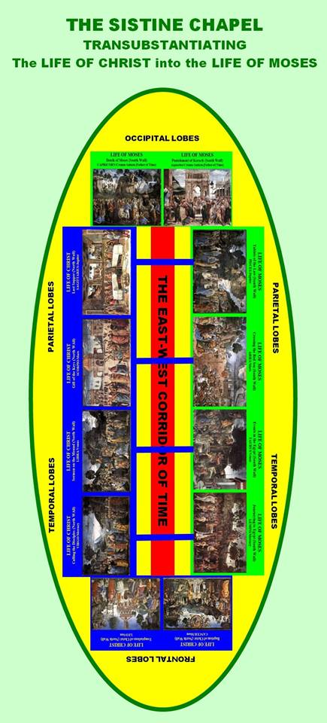**That is why the Hebraic alphabet is written from east to west: east-west-corridor-of-time. It can be interpreted that ALEPH א and BETH בּ are on their way out of creation. If the reader knows Hebrew and the mythoi of Christianity this coming in and going out of creation is obviously an example of the Second Coming of Christ; for the reason that, the Hebraic alphabet going out of creation illustrates the death of the first appearance of Christ when the Hebraic alphabet first came into creation. This Hebraic Alphabet coming in and going out of creation is symbolically an eternal repetitive never-ending cyclic process that takes place nanosecond by nanosecond in the dynamics of the psyche.**

**Studying the whole of the Prologue of the Zohar and then studying the first word of Genesis: BERESHITH בּראשית and then the first two verses of Genesis it can be conceptualized how the Hebraic Alphabet[14] was created. Each of the first nine ARCHETYPLE letters of the Hebraic Alphabet transubstantiates from the north side of Chartres Cathedral to the south side of the cathedral creating the EXISTENTIAL Hebraic letters (10-18); thus, the COMIC Hebraic spiritually and psychically letters travel down the east-west-corridor-of-time.**

**The reason that I discussed all this about the first word of Genesis: is; because, I had to lay the back-story to the one of the interpretation of the word BERESHITH בּראשית in order to illustrate how the three pyramids on the Giza Plateau is mystically reanimated nanosecond by nanosecond. This is why the transept of Chartres Cathedral is merely there mystically for a nanosecond of time inferring that the entire cathedral is merely there for a fraction of a second and then reappears as if it is permanently structured.**

**I fully understand that many readers will not understand my discussion on the first word of Genesis: BERESHITH; for the reason that, they neither understand symbolism nor the Hebraic Alphabet; however, I also initiated this discussion to illustrate to the reader how much can be mystically culled out of the symbolism of just one word of the bible and how difficult it is to do so and I had not even tapped the tip of the iceberg that symbolize BEREHITH. I will again talk about BERESHITH again; but, not so mystically.**

**The first and second circles radiating out from the center image in the West Rose Window at first glance look like a coffin; however, a closer look illustrate that it is not a coffin as illustrated in the North and South Rose Windows in Chartres Cathedral. The empty coffin in the King Chamber of the Great Pyramid obviously symbolizes the Resurrection of the Dead; thus, that coffin could have been used to symbolize that an Initiatic Visionary Experience blessing the initiate with Horus (Christ) consciousness represents the initiate’s rite of passage.**

**I point these three ROSE WINDOWS out because the first circle in the North and South Rose Windows radiating out from the center image exudes twelve coffin-like images. I wrote a detail analysis on these three Rose Window illustrating that the North Rose Window transubstantiates over to the South Rose Window and in the process of bridging the Crossing the dynamics of the West Rose Window are mystically embedded into its stain glass window: EZEKIEL’S MERKABAH IN CHARTRES CATHEDRAL[15]. The analysis of these three Rose Windows is actually revealing the same spiritual paradigm lay out on the Giza Plateau’s Pyramid Complex from a Christian perspective.**

***I advise the reader to visit the link to the image. This site gives a detail description of every stain glass window in Chartres Cathedral and every single feature in the stain glass window can be clicked on and a larger image is provided with a description of it.***

**This same spiritual paradigm is seen in the Sistine Chapel where the Life of Christ on the North Wall is transubstantiated over to the Life of Moses on the South Wall. I have written two books[16] analyzing the Sistine Chapel symbolism and I’m presently working on a paper illustrating Ezekiel’s Merkabah in the first chapter of Genesis and the Sistine Chapel, which will augment my paper on Ezekiel’s Merkabah in Chartres Cathedral.**

**Not to be boring; but, this same spiritual paradigm is structured into the first word of BERESHITH בּראשית, which is illustrated in the cover-image of this paper. It is absolutely astonishing from an iconoclastic perspective that the entire spiritual paradigm laid out on the Giza Plateau’s Pyramid Complex is codified into one word of the Torah: first word of Genesis: BERESHITH בּראשית.**

**Because of the perfection that the world’s religious literature, artworks and monuments are laid out in on a symbolic level it is obvious that the message is that all of this spiritual knowledge already resides within the soul and somehow the soul summarily dismisses it; thus, suffering an amnesia of consciousness.**

**There is no evolutionary process to learning this spiritual esoteric knowledge seeing that all the information concerning the spiritual psychic process is wholly present in the first written (Revealed) letter/word of Genesis: BETH בּ and the first hidden letter/word: PEI פ, which mystically formulates the first word of Genesis: BERESHITH בּראשית via the first two written letters/words of Genesis: BETH בּ and RESH ר. The letter/word RESH ר symbolizes the human Head/Skull. The whole of the Judaeo Christian Scriptures: Old and New Testaments are commentaries on these first two letter/words and the hidden letter/word PEI פ.**

**The sacred scripture interprets itself and it does not need the hubris: biases, prejudices and preconceived notions of ego-consciousness to elucidate its spiritual missive. The above example of the first two written letters of Genesis: : : BETH בּ and RESH ר transforming into two letters/words formulating the first word of Genesis: BERESHITH בּראשית is an ideal example of how to properly read the sacred scriptures. This is obviously the primary key to how to decode the bible. This is why originally there were no jots, tittles or verbs surrounding the texts of the Torah. The jots, tittles and verbs were added on later to give the surface (Revealed) texts of the Torah an applicable storyline that will also aid in interpreting those Hebraic letters/words that narrate its texts. Think of every word in the sacred scriptures storyline as being formulated by a number of Hebraic letters/words group together to form a spiritual concept. The jots, tittles and verbs symbolize the first letter/word of Genesis: BETH בּ and the letters/words without jots, tittles and verbs are symbolized by the esoteric (Hidden) Hebraic letter PEI פ that inundates and surrounds the letter BETH בּ. The letter PEI פ symbolizes the Mouth of God and BETH בּ symbolizes the House of God (Elohym); thus, it can be envisaged that the Torah is the House of God formulated by the Mouth of God.**

**Think of BERESHITH בּראשית or the birth of Christ: i.e. TAV, SHIN, RESH, QOPH as the BIG BANG that creates the universe. This is RESH ר slamming into BETH בּ from the north reanimating the psyche. Individually, as human beings, we see the expansion of the universe in our personal psychic bubbles; for the reason that, our personal unconscious minds are memory databases. We neither collectively nor individually see the universe being reanimated nanosecond by nanosecond; nonetheless, it does; but, these slight changes in time we called ‘living in time’. Neither collectively nor individually do we see those changes as repetitiveness. If we did see it as repetitiveness then individually we would all have a very boring life.**

**There are three small pyramids interpreted as being Queen’s Pyramids south of the Menkaure Pyramid going horizontally east to west symbolizing the east-west-corridor-of-time; whereas, there are an additional three small pyramids on the east side of the Great Pyramid: Khufu’s Pyramid place vertically from north to south.**

**It is obvious that these six small pyramids symbolize a mini-version of Cygnus X-3 coming from the north going south CROSSING the Orion Constellation, which symbolizes the east-west-corridor-of-time. The number three has an aggregate of six, which creates symbolically the Star of David and the second set of three creates the Seal of Solomon. King David collected the materials for the Temple of God and Solomon build the Temple of God with that material; however, this is done on a psychic level conceptually manifesting the CROSSING: i.e. Khafre Pyramid: *“Along the centerline of the pyramid on the south side was a satellite pyramid”*[17]. These seven small pyramids symbolize a sphere with the seventh satellite pyramid as the center. These seven small pyramids are extremely important; because, they infer every seven imaginable: Seven-day week, Seven Liberal Art, Seven Sun Signs, Seven Light Chakras, Seven Sacraments, etc., etc.**

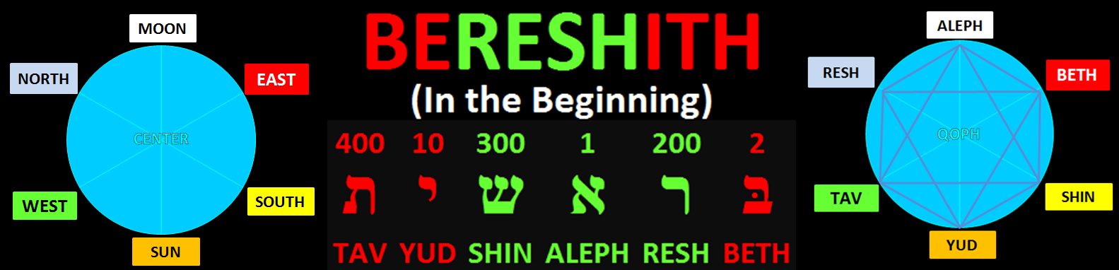**The first word of Genesis: BERESHITH בּראשית symbolizes this very same concept of a sphere and creating mini-version of the main text of the first chapter of Genesis before it is written.**

**QOPH ק is place in the center; because, it is the first letter in the spelling of Christ: krst in Greek using Hebrew letters: קרשת. Notice the skip pattern sequence of the letters in the word BERESHITH בּראשית: TAV ת (400), SHIN ש (300) and RESH ר (200) the next letter that is schedule to come into Genesis is QOPH ק (100).**

**When the mathematics is done on this BERESHITH בּראשית sphere the letter BETH בּ (2) is the first letter of Genesis; thus, the radius of the circle it is number two (2) and the diameter is four (4) and the circumference is 12.566… x 4 = 50.265… There can only be whole letter, words, verses and chapters and books in the bible so the factions thereof are omitted. That would suggest fifty (50) chapters in the book of Genesis. That could be coincidental: actually there is nothing coincidental in the bible; thus, what is the volume of said sphere? The volume of said sphere is 33.51… That is incredible; because, realistically there are no directions in a sphere so 33.51 can be seen in its reverse format: 1533. There are exactly 1533-verses in the book of Genesis. This sphere I take to be the new raison d’etre given to a worthy initiate and this individual will go through life spiritually protected. There is more to this; but, I will not discuss it any further here.**

**However, the first word of Genesis: BERESHITH בּראשית extrapolates out to a ten letter formula, which I have called the Genesis Formula. The whole of this first word of Genesis has to do with ‘being’ the SHECHINAH’S (Divine Presence) matrix. I am discussing it here because when the Genesis Formula is placed into a circle if formulates mini-versions of what is written into the main texts of the first chapter of Genesis. Thirty-two (32) times the word ELOHYM is mentioned in the first chapter of Genesis and an analysis of those uses of the word ELOHYM show how that word formulates via sacred geometry the Kabbalistic Tree of Life and the STAR OF DAVID graphically. What is more astonishing is to learn that the SHECHINAH’S (Divine Presence) matrix is the original source material that wrote the sacred scriptures of the world. The Kabbalistic Tree of Life and the Star of David are graphically depicted in the SHECHINAH’S (Divine Presence) matrix, which per se is incontrovertible evidence that the SHECHINAH’S (Divine Presence) matrix is the sacred scriptures’ original source material. The Crown of Creation: Keter is the first Sefirah of the Kabbalistic Tree of Life. As it can be seen the four ones: symbolizing the spiritual forces of creation formatting two Merkabah wheels creating the Vesica Piscis: i.e. seat of the Merkabah. The two wheels would be the Great Pyramid and Menkaure Pyramid. Khafre Pyramid would symbolize the Vesica Piscis.**

**The reason that I discussed these mini-versions of the Kabbalistic Tree of Life, the Star of David and Keter is; because, they show how mini-versions of concepts are a basic paradigm of the spiritual process as envisaged in the Great Pyramid’s King Chamber prior to envisaging the larger versions of them on the main platform of the Giza Plateau’s Pyramid Complex.**

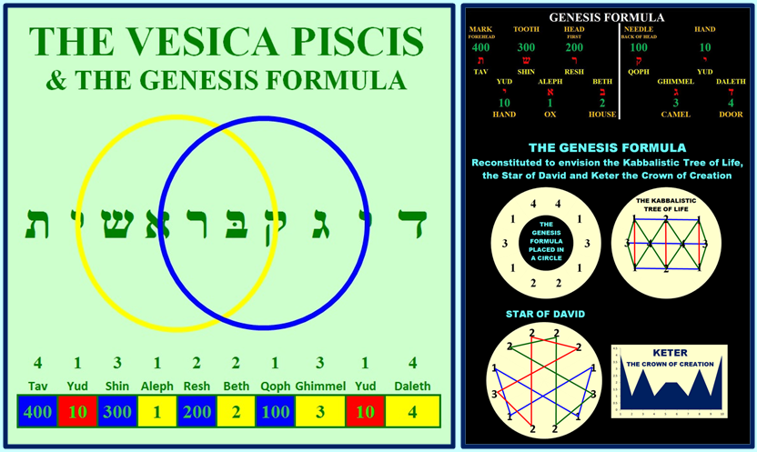**The mini-version of a concept(s) is selected as the best part of an initiate’s psyche when he or she is gifted with the initiatic visionary experience. This symbolically takes place in the psyche when Cygnus X-3 passes through the Orion Constellation, which symbolizes Osiris: i.e. the worthy initiate. This taking the best parts of a worthy initiate’s psyche is very similar to how Catholicism: Roman Catholic Church takes the best parts of other religions and incorporates them into its fold. Those best parts of the psyche of the initiate are spiritualized that gives the initiate a new raison d’etre. Essentially, such an Initiatic Visionary Experience takes away addiction(s) and weakens immensely the initiates biases, prejudices and preconceived notions to the point that they all eventually fade away from the psyche leaving TRUTH in plain sight to be envisaged.**

**Thus, the mini-version(s) selected out of the psyche of a spiritualized initiate become his or her lifelong raison d’etre.**

**For example: Mary Baker Eddy (July 16, 1821 – December 3, 1910)[18] was in her late forties when she had the vision and she was instantly cured of an injury she was about to die of. She was reading the bible at the time and the bible became her raison d’etre and she founded the Christian Science Church, which is a worldwide organization.**

**Carl G. Jung (26 July 1875 – 6 June 1961)[19] was a psychiatrist at the dawn of the twentieth century when he had the vision and he spent the rest of his life trying to understand it from a psychological perspective. He founded Jungian Psychology, which is a worldwide organization.**

**William Griffith Wilson (November 26, 1895 – January 24, 1971): Bill W.[20] was an alcoholic and he was in a hospital in 1935 and he thought he would spend the rest of his life in a hospital because of his acute alcoholic addition. When the hospital doctor shut the door of the room, he was in, ‘the room lit up’ and he said to himself, “so this is the God of the preacher”. Bill Wilson when on to cofound the worldwide Alcoholics Anonymous program.**

**Of course not everyone has to create a physical worldwide organization per se; however, spiritually, each initiate’s personal world has to be filled with his or her personal raison d’etre. As it can be seen with these three examples each of them stayed within the confines of that which enamored their psyches, which literally became their lifelong raison d’etre; however, each of their raison d’etre were saturated with religious spirituality only after that received the vision.**

**WASHINGTON DC’s NATIONAL MALL**

**ESOTERICALLY constructed by FREEMASONRY**

**T**

**he manner in which Washington DC’s National Mall was esoterically laid out is a perfect *‘living example’* of the spiritual paradigm, which is explained in all the examples I mentioned above: SHECHINAH’S (Divine Presence) matrix, the Giza Plateau’s Pyramid Complex, and the first word of Genesis: BERESHITH בּראשית, Chartres Cathedral and the Sistine Chapel.**

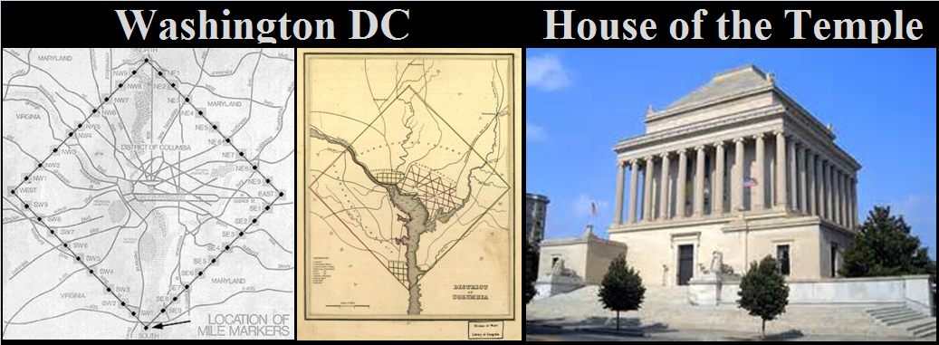**Washington DC is laid out on the SHECHINAH’S (Divine Presence) matrix and the National Mall is a mini-version of that SHECHINAH’S (Divine Presence) matrix and the TRINITARIAN PARADIGM. I hypothesize that the entire country of Egypt can be similarly laid out like Washington DC via the SHECHINAH’S (Divine Presence) matrix; though, I cannot prove or give credence to that hypothesis. In the cover image of this paper is an image of Washington DC’s National Mall. There is no doubt, in my mind, that Freemasonry was building the Temple of Democracy. Note how the map of Washington DC mirror-images Freemasonry’s House of the Temple, which is in Washington DC built at the turn of the twentieth century.**

**However, the UNITED STATE OF AMERICA’s mythoi began not in 1776 per se; rather, it all began back at the dawn of the Judaeo Christian Scriptures. That sounds inane; nonetheless, it’s true. Go fast forward to 27AD when Christ died on the Cross. Exactly, 1533-years later Queen Elisabeth executed her sister Mary, which is a reverse mythology of the New Testament narratives of Jesus and John the Baptist’s families. Mary instead of John the Baptist get killed by a queen; rather, than John being beheaded by a king. Also in the year of 1560AD (27 + 1533) the Roman Catholic Church was expelled from England. Right after the book of Genesis (1533-verses) is the book of Exodus that narrates the exodus of the Israelite people from Egypt; thus, history is rewriting the mythoi of the bible in reverse. The Roman Catholic Church (iconography - symbolism) was expelled from the tyranny of Protestantism (iconoclasm – non-symbolic).**

**Fast forward again to 1776, which is precisely 216-years. The numerics are absolutely amazing when you consider that 216 is the cube of six: i.e. 6³, which symbolized the spiritual sun. The SHECHINAH’S (Divine Presence) matrix was already in the minds of Freemasonry at the beginning of 1776; because, Thomas Jefferson wrote a letter to the Governor of Virginia requesting that the State of Virginia secede land for the seat of government. This matrix: “ten mile square” is explicitly laid out in Article 1, Section 8 of the United States Constitution. There is more biblical mythology codified into the Civil War and Abraham Lincoln.**

**I believe that Washington DC’s National Mall was fully designed back in 1776; but, stretching out the time in laying out the National Mall is similar to how the Roman Catholic Church built the cathedrals of Europe no matter what the Church’s spin doctors may have to say about the duration of the time it took to build them.**

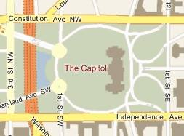**This correlation with historical dates is incontrovertible evidence that Freemasonry worked esoterically with the teachings and symbolism of the Roman Catholic Church.**

**The Temple of Democracy: Washington DC’s National Mall has a very special raison d’etre to it. The Capitol Building is the pivotal point of the entire city of Washington DC. Go to Map Quest on the Internet or any modern map of Washington DC and hone in on the four streets: *1st Street NW, 1st Street SE, Constitutional Avenue and Independence Avenue* that surround the Capitol Building. The landscape within the confines of those four streets that the Capitol Building sits in is in the shape of a human SKULL. Is this a coincidence? I, personally, do not think so.**

**Also on 1st Street NW there are two monuments that look like eyeballs: the Monument of Peace looks down Pennsylvania Avenue towards the White House and Garfield Monument looks down at Jefferson Memorial. The two streets that flank the National Mall are named after the two documents that Thomas Jefferson wrote.**

**This is a weird positioning of the SKULL looking west, which is in reverse of the Sphinx on the Giza Plateau, which is looking east. The Capital Building; though, is looking east. Initially, I thought this had something to do with the entrances of Chartres Cathedral (west) and the Sistine Chapel (east); however, the Capitol Building and the Skull within the confines of those four streets is inferring something I at the moment cannot wrap my mind around. The only thing I can suggest as to why this inconsistency is here is because Freemasonry is saying that those understanding esotericism can wrap their minds around any psychic situation. This latter is inferred by the Capitol Building remaining stabilized without moving. The Capitol Building remains facing east. If the SKULL turned around and the Capitol Building turn with it with it that would be a totally different psychic scenario; whereas, by the Capitol Building remaining stabilized the symbolism suggest that only the mind is wrapping itself around the psyche problem and considering all possible solutions to life.**

**Also consider how Washington DC is positioned on the Potomac River just as Cairo is situated along the Nile River. Also consider that Cairo is also position not too great a distance from the Mediterranean Sea just as Washington DC is position not too far from the Atlantic Ocean.**

**The whole city of Washington DC centers on the Capitol building where the streets going vertically from north to south are numerically numbered; whereas, the streets going from east to west are alphabetized. This alphanumerical design is precisely how every single Hebraic and Greek letter of the bible is structured in the Old and New Testaments; however, most people only see the letters and not the numbers. The numbers symbolize abstract thought coming from the north crossing the alphabet: i.e. mythoi of the bible.**

**Thus, the National Mall from the Capitol Building to the Lincoln Memorial is essentially traveling down the east-west-corridor-of-time; whereas, the transept going from the White House to Jefferson Memorial is going from north to south. Center to the transept is the Washington Monument, which is an obelisk that symbolizes the cosmic rays radiating out from Cygnus X-3.**

**There is a new president in the White House essentially in a cyclic period, which indicates that the raison d’etre of the new president is sent to Congress: Senate and House of Representatives to legislate laws based upon those things that enamor the president’s psyche.**

**There are three branches of government: TRINITARIAN PARADIGM: Executive (President), Legislative (Congress) and Judiciary (Supreme Court).**

**The idiocy that the American People witnesses in the attitude and conduct of the Senate and the House of Representatives is basically the collective psyche of the whole of the United States population. Democracy literally means “mob rules” and this is why there are checks and balances in the government.**

**From a spiritual perspective the whole of the Temple of Democracy is to aid the USA citizenry to go from slavery to being a free man or woman. Most people have no idea, because of their belief systems, that they are predominantly slaves.**

**Life in the world is a very harsh reality and basically every single human being is a slave. For example: generically college students graduate with a debt burden that essentially controls his or her finances for the rest of his or her life, which is an extremely harsh laborious burden; in contrast, the minimum wage earner is in just as bad a situation on the other side of the pendulum so-to-speak; because, he or she is living pay-check by pay-check. Lose your job and you are in a dire financial situation. That is just one example; because, there are many life contingencies that govern the individual’s life: i.e. additional credit burdens, raising children, illnesses, obligations to society, family and friends, etc.**

**The whole purpose of life is to be content with the conditions of life. The initiate should not allow his or her life’s contingencies to burden him or her psychically: i.e. he or she can live a very happy and contented life regardless of the outer world’s burdens. This is what religion is all about.**

**When the reader considers the raison d’etre expressed on Washington DC’s National Mall consider that it is Freemasonry’s raison d’etre that is being expressed. The first president is George Washington a Freemason and his raison d’etre transubstantiate over to the Jefferson Memorial: i.e. the Declaration of Independence and the Constitution of the United States, which is then what governs the Congress: Senate and House of Representatives and the Supreme Court sits behind the Capitol Building overseeing Congress with checks and balances. This is just an example of how the spiritual paradigm works in the psyche of the initiate.**

**This is why the Lincoln Memorial sits at the end of the National Mall; because, Abraham Lincoln symbolizes the door way into the outer world: i.e. “go west young men”. Remember that it was Abraham Lincoln that signed the Emancipation Proclamation that freed the slaves. Recently, between 2000 and 2008 on the eastside of the Capitol Building a large extension to the Capitol Building was built and its main entrance hall is called, Emancipation Hall and that is why a mulatto president: President Barack Hussein Obama II: half white and half black was elected president in November 2008.**

**There were actually more white indentured slaves in the Northern part of the United States during the Civil War then there were blacks slaves in the south; though, that is rarely talked about. Those that read the mythoi of Abraham in the bible will get clues as to the esoteric nature of religious teachings. Remember that Abraham in the bible made sure that Hagar and Ishmael were taken care of by angels. The mythos of President Abraham Lincoln has everything to do with the mythoi of Abraham of the bible.**

**Let me give a number of examples of religious esotericism codified into the American mythoi:**

* **It is said that there were 365,000 Federal Soldiers that died in the Civil War and 258,000 (nice round numbers) Confederate soldiers that died in the Civil War. That is very interesting; because, those numbers coincide with the 613-laws that are derived from the Ten Commandments: 365-Thou shalt not laws and 248 + 10 - Thou shalt laws.**
* **When the gematria (numerical) value of the Hebraic names of Abraham’s two families: Hagar and Sarai/Sarah are totaled the quotient is 1863. Isn’t it a bit just too coincidental that Abraham Lincoln signed the Emancipation Proclamation on January 1st 1863?** 
  + **The numbers 1, 3, 6 and 8 are the four months with 30-days in the Zodiacal/Calendar year, which creates a butterfly pattern and there is only one way to get the other eight months to formulate two other exact butterfly patterns. When all three butterfly patterns are put together they create an image of the STAR OF DAVID. The name Lord Jesus Christ has the Gematria value of 3168. Christ is born in Bethlehem of Judea at 31.68 North Latitude.**
* **Isn’t it a bit too coincidental that between the years 2004-2007 the sacred geometry of the Vesica Piscis was etched into the landscape that surrounds the Washington Monument? The Vesica Piscis symbolizes Christ consciousness.**

**THE SPHINX SOLVES ITS OWN MYSTERY**

**AND IT ALSO SOLVES THE MYSTERIES OF**

**THE GIZA PLATEAU’s PYRAMID COMPLEX**

**I mentioned above that the United States Capitol Building sits on the landscape that symbolizes a skull: i.e. Jesus died at Golgotha: Place of the Skull. I did mention that the Capitol Building faces east. The front of the building is in the east. This is precisely how the Sphinx sits on the Giza Plateau’s Pyramid Complex. The Capitol Building not only symbolizes the Sphinx; but, it also symbolizes the Great Pyramid; because, the sun travels down the east-west-corridor-of-time. That is the point of the Sphinx and the Capitol Building facing east; because, it is a never-ending task to travel down the east-west-corridor-of-time.**

**Another reason that the Capitol Building faces both east and west simultaneously; because, it symbolizes both the Sphinx facing east and it also symbolizes the Great Pyramid that is going down the east-west-corridor-of time.**

**Everything behind the Sphinx and the Capitol Building is an afterthought. It is in the past and only NOW can be experienced. This is why the Capitol Building is symbolically in a position, which can be called TIMELESSNESS. Look at the cover image of this paper. The Sphinx like the Cave of the Birds and the Well of Souls sits outside of the TIME/SPACE CONTINUUM: i.e. meaning outside the numbers 1-8 representing the portion of the SHECHINAH’S (Divine Presence) matrix that symbolizes the TIME/SPACE CONTINUUM; whereas, all the nines in the matrix symbolizes TIMELESSNESS.**

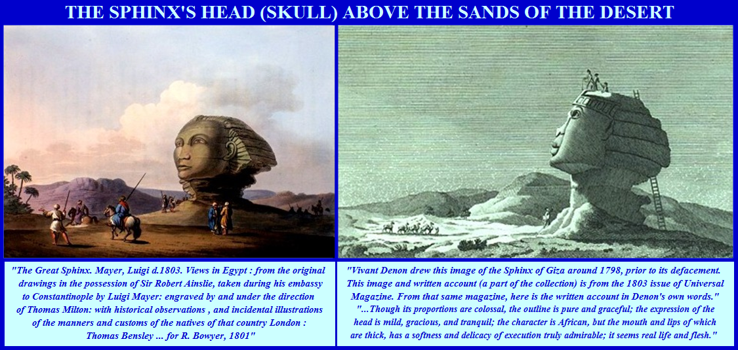 **When modernity first saw the Sphinx only its head was above the sands of the desert. Below are two images of the Sphinx, taken in the eighteenth and nineteenth centuries. Vivant Denon writes that the image of Sphinx, before it was damage, can be envisaged as an African; thus the work of the New York City’s (USA) Police Department’s forensic expert Frank Domingo validates that observation made by Vivant Denon.**

**If you think about the Sphinx, which represents the Sun: i.e. ego-consciousness it is obviously symbolizing one of the frontal lobes of the brain: i.e. temporary memory. The Sphinx: i.e. Sun is mirror-imaging the constellation of Leo and it has to continuously do so to maintain it character and outer features. That is precisely what the ancient Egyptians did when they mirror-imaged simultaneously the Orion Constellation and the Cygnus X-3 Constellation onto the landscape of the Giza Plateau.**

**I have to throw a money-wench into the fray. Knowing that the Sphinx sits outside of TIME/SPACE CONTINUUM in the pattern of the MATRIX OF SHECHINAH’S (Divine Presence) matrix I am more apt to believe that the ancient Egyptians deliberately created water damaging features on the Sphinx and in its enclosure via their sciences to illustrate how the unconscious mind batters ego-consciousness continuously everlastingly. The unconscious mind is symbolized by water of any kind and the universe at large. John Anthony West may not like that hypothesis; but, TRUTH is what it is.**

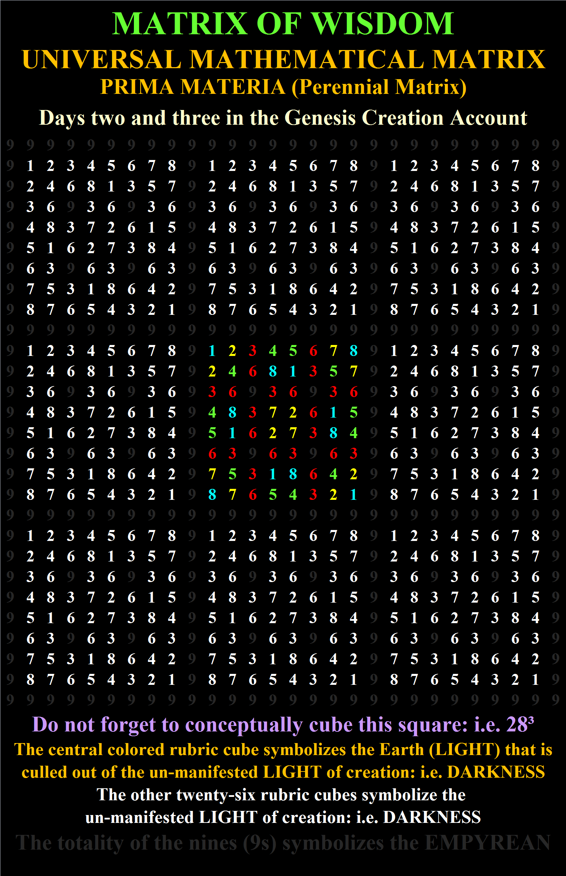**The Sphinx’s Temple was built from the sandstone rock surrounding the body of the Sphinx; thus, that is incontrovertible evidence that the Sphinx was mirror-image from the image of the helical-rising of the Leo Constellation. The question is, what could possibly be the material that could be use to build the Sphinx’s Temple? The earth, moon and planets circle the sun; however, the Earth’s planet is the only material that can be used to build the Sphinx’s Temple in the outer world; however, the sun, moon and five other planets are ethereal concepts in the psyche, which are known as the Sun Signs of Astrology, which govern the cerebral lobes. These cerebral lobes have to do with psychic content of the skull not that which is built outside of the skull.**

**Thus, the Cancer Constellation: i.e. unconscious mind, which is controlled by the Kamea of Moon, takes over. The Cancer Constellation is the second frontal lobe of the brain; ego-consciousness (Leo) and the unconscious mind (Cancer) symbolizes the westward journey of the psyche. The unconscious mind is continuously releasing the sun upon the world. Humans see the sun rising and setting on a twenty-four hour cycle; however, realistically the sun is released by the unconscious mind nanosecond by nanosecond.**

**The SHECHINAH’S (Divine Presence) matrix is the psyche and when its numerics are cubed it exudes one-thousand (1000) cells (10³); however, four-hundred and eighty (480) of them represent the numbers one (1) thru eight (8) and the other five-hundred and twenty (520) cells are symbolized by nines. When the other twenty-six of these cubed matrices surround the central matrix the numerics are twenty-eight (28³) squared: 21,952. This quotient 21,952 exudes 12,960 cells for the numbers one (1) to eight (8). The quotient 12,960 is precisely half of equinoctial years in a complete Equinoctial Zodiacal Cycle. The number nines (9s), which only radiate out 8,992 cells is just shy of 3,968 cells to complete the Equinoctial Zodiacal Cycle. The number 3,968 / 25,920 = 0.1530… The number 153 is the aggregate of seventeen (17) and it is the numerics of the Vesica Piscis, which symbolizes the Initiatic Visionary Experience.**

**These numerics from the SHECHINAH’S (Divine Presence) matrix are how the ancient astronomer’s learned of the Equinoctial Zodiacal Year. The Ancient did not need to watch the skies continuously never-endingly to envisage it. The point that I am trying to convey here is that all of this knowledge about the initiate’s psyche is embedded in this matrix and it is imbued into the abyss of the outer materialistic realm. How is any of this possible if the matrix is not a commentary on the psyche?**

**This LIGHT and DARKNESS paradigm are explicitly laid out in the first chapter of Genesis. The Calendar Months are expressed via the first six days of creation and the other six are signs of the Zodiac laid out in the first two verses of Genesis and the second, third and fourth chapters of Genesis. The pattern is laid out in the Sistine Chapel in the Life of Christ’ (six Zodiacal Signs) and the Life of Moses’ (six Calendar Months) frescoes. I believe that this pattern also is meant to symbolize the Earth’s Terminator.**

**GOBEKLI TEPE: CIRCLE - D**

**Gobekli Tepe is an archeological site in Turkey. I am not an archeologist. I know nothing about archeology; however, my expertise is in interpreting esoteric symbolism or at the least esoteric symbolism and mythology that I am presently aware of after four decades of researching those disciplines.**

**I, personally, hate FAKE NEWS and when someone manipulates data in any manner to confirm his or her theories I am not afraid to expose it. Gobekli Tepe – Circle – D is quite obviously a depiction of a Zodiacal Cycle; however, researchers that have visited this archeological site have tossed in some weird theories as to how the Zodiacal Cycle is laid out in CIRCLE – D. The Zodiacal Cycle no matter what culture displays it is set up in the selfsame manner as every other culture. What I mean by manipulated data is that Andrew Collins took what is called the “Holed Sighting Stone” and placed it horizontally along the back wall of the CIRCLE – D enclosure. When you look at all the original aerial photographs of the Gobekli Tepe archeological site it is clear that that “Holed Sighting Stone” is vertical.**

**Andrew Collins and Rodney Hale shocked me with the images above showing the “Holed Sighting Stone” with a hole in it positioned horizontally along the back wall of CIRCLE – D flanked by stones #43 and #30; because, it appears that the “Holed Sighting Stone (I don’t know why this stone is not 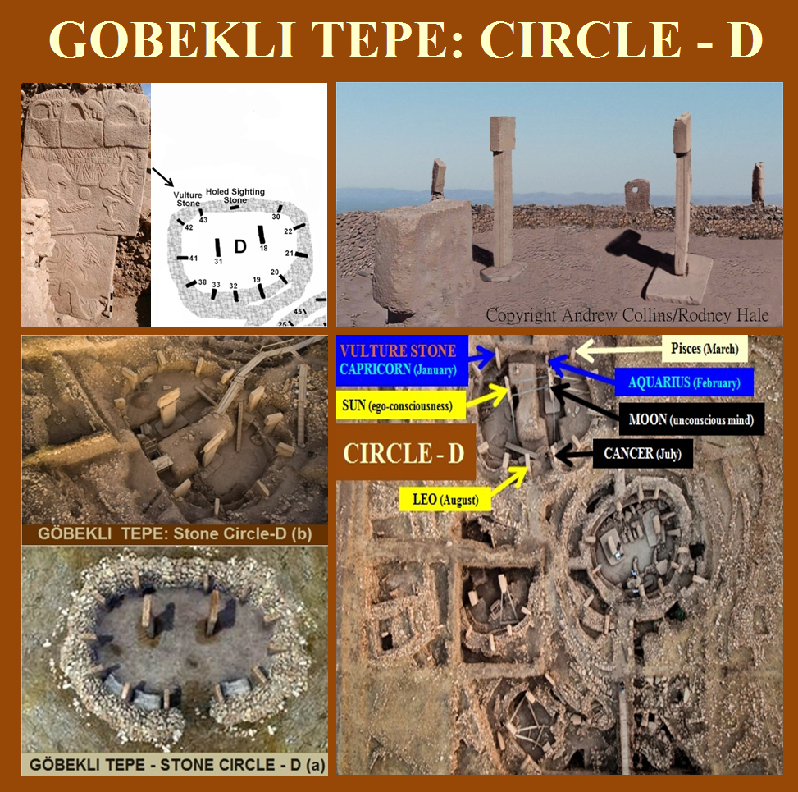numbered)” in CIRCLE – D was manipulated. I placed all these different images of CIRCLE – D here so there would be no misunderstanding of what I am discussing. I cannot fathom why Andrew Collins wants that stone positioned like that when it initially wasn’t set in CIRCLE – D that way by the ancients.**

**In addition the stoned numbered “30”, which I earmark as Pisces (March) also has a hole in it. This hole in stone #30: i.e. Pisces can be seen if you enlarge the image above that has the caption beneath it “GOBEKLI TEPE: Stone Circle–D (b)”. Why this hole in #30 is not mentioned by the researchers I don’t know. It is as if the ancients wanted this “Holed Sighting Stone: Aquarius (February) and stone #30: Pisces (March) to be recognized as being aligned with each other and the ramifications of that suggestion would be that Capricorn (January) and Aquarius (February) symbolically governed by Cronus/Saturn: Father of Time releases the sun (ego-consciousness) down the east-west-corridor-of-time, which is symbolized by the four zodiacal signs: Pisces, Aries, Taurus and Gemini on the left side of the brain.**

**These four zodiacal signs: Pisces, Aries, Taurus and Gemini assigned to the left side of the brain were perfectly and artistically embedded literarily into the Judaeo Christian Scriptures via their Equinoctial periods of time. Not many people know of this. One of the ‘in your face clues’ is that Christianity began at the beginning of Piscis: the Fishes and everybody talks about it; however, the other three signs: Aries: the Ram, Taurus: the Bull and Gemini: the Twins are never ever talked about zodiacally. The Taurus the Bull is a no brainer when you realize the Osiris was called the Bull God and in Egypt that is who they worshiped. Also remember that Abraham was given an alternative victim to execute: sacrificial Ram, which symbolizes the age of Aries.**

**These four zodiacal signs also symbolize the four elements: Fire, Earth, Air and Water, which symbolizes the four elements that create the material universe: Electromagnetism, Weak Bosons, Strong Gluons and Gravitons. The first four days of creation symbolizes the LIGHT of creation, which symbolizes these four basic elements. The four gospels of the New Testament symbolize the Fixed Quadruplicities, which have all four elements in them.**

**The animals sophisticatedly carved coming out of the T-Stone columns obviously, at least to me, symbolize animalistic behavior: i.e. biases, prejudices and preconceived notion, being worked out of the psyche’s raison d’etre.**

**Modernity tends to think dogmatically and traditionally that the bible began about 4004BC because that is the date that Bishop James Ussher (4 January 1581–21 March 1656) ushered *(deliberate pun)* into the religious conversation as the commencement of the dawn of creation via his take on the numerics of the bible; for the reason that, the bible begins with the creation story; whereas, Saint Augustine, a thousand years earlier, saw that the bible historically recounted the periods going back to over 6000BC; however, Saint Augustine did not believe what the historians believed. He believed that humanity went back millions of years.**

**Astrology symbolizes the cerebral lobes of the brain and explains on a symbolic level how the brain is activated nanosecond by nanosecond. There is literally no other reason for the science of Astrology; though, there are those infidels and profane people that believe it is a Fortune Telling mechanism.**

**The first eleven chapters of Genesis symbolizes the Matriarchal culture that in turn symbolizes the birth of a child and the mother educating her child to puberty and the twelfth chapter of Genesis symbolizes the Patriarchal culture. I wrote a paper on the first eleven chapters of the bible being symbolic to how the Mother Church: Saint Peter’s Basilica and Bernini’s Square[21] was architecturally structured based upon the esoteric mathematics of the first eleven chapter of Genesis. That Matriarchal period symbolizes Gemini, the period of the pyramid builders.**

**The image in the above illustrates how I aligned the Zodiacal Cycle to CIRCLE – D. It was not necessary for me to earmark every zodiacal sign since the stones not marked earmark themselves from those that I did zodiacally name. The mystical doorway into any Zodiacal Cycle is through the occipital lobes: Capricorn and Aquarius, which are governed by Cronus/Saturn: Father of Time; hence the reason the journey down to the frontal lobes: Leo and Cancer is designated as the east-west-corridor-of-time. The initiate has to remember that the star studded universe per se symbolizes TIMELESSNESS; thus, there is really no time factor involved; though, the count of 25,920 years clocks off each of the zodiacal signs as 2,160-years. I am pointing this out; because, it is the sun that travels through the universe via TIME. Understanding this conceptually allows the initiate to realize that even if the universe is spinning per se to maintain its balance it does so in alignment to the velocity of the earth speed otherwise the star studded universe would be in a total disarray: chaos.**

**The two T-Stone pillars flanking the opening-doorway to CIRCLE – D (worldly temple) are Boaz and Jachin, which are seen outside of Chartres Cathedral: two towers: Sun and Moon and they are also seen outside of the Jewish and Masonic Temples. These two pillars are not allowed into the temple unless they are mystically alchemically married.**

**The small stones between the T-Stones symbolizing the zodiacal signs symbolize the star studded universe. That is a given and it is so obvious it shouldn’t even be mentioned. I mention it; because, there will be some out there that will not recognize the obvious.**

**When the Zodiacal Cycle is clocked off counterclockwise or the Calendar year is clocked off clockwise the results are still the same. Left of Leo on the right side of the brain is Virgo, Libra, Scorpio, Sagittarius and Capricorn and on the right of Cancer on the left side of the brain is Gemini, Taurus, Aries, Pisces and Aquarius. That is a no-brainer; but, it seems as if people still get it wrong. Notice that the T-Stone symbolizing Cancer is small and sit upon smaller stones ratcheting it up to the same height as the T-Stone symbolizing the Leo and the other T-Stone creating the zodiacal cycles..**

**The right side of the brain: i.e. parietal and temporal lobes symbolizes abstract ideas, which are symbolized as the Quadrivium’s four mathematical sciences transubstantiating over to the left side of the brain; contrarily, the left side of the brain’s parietal and temporal lobes symbolizes LOGIC; whereas, frontal lobes symbolizes GRAMMAR and the occipital lobes symbolizes RHETORIC (the sun continuously being released conveys the same raison d’etre: personality and character). The Seven Sun Signs and the Seven Liberal Arts are all predestine to exude the spiritual paradigm; because, on the bottom of the large Moon T-stone in the center of CIRCLE – D are seven flightless ducks, which symbolizes the unconscious mind exuding the universal pattern of seven.**

**The pattern of the Seven Sun Signs that are envisage are seen in Capricorn and Aquarius being governed by Cronus/Saturn and Leo and Cancer are governed by the Sun and Moon respectively; whereas, Sagittarius and Pisces are governed by Jupiter/Zeus, Scorpio and Aries are governed by Mars, Libra and Taurus are governed by Venus and Virgo and Gemini are governed by Mercury.**

**I have incorporated a great deal of information in image below; though, it may look simple to some; however, it is actually quite complex and it needs a great deal of contemplative thought to understand.**

**I have included in this image the three Quadruplicities: Cardinal (yellow), Fixed (red) and Mutable (green) and the four Triplicities: Fire, Earth, Air and Water. The Mutable (green) Quadruplicities are not allowed down the east-west-corridor-of-time; because, they cannot be pithily expressed in the outer world. As I said the mathematical sciences merely symbolizes the abstract dynamics of the psyche. The Mutable (green) Quadruplicities appear to interpret the rudiments of the psyche: i.e. Arithmetic (Mercury) and the entire cosmology of the psyche: i.e. Astronomy (Jupiter). Neither of these psychic factors is recognized in the outer world even by expert psychiatrists, mathematicians and astronomers; yes, the individual can give consideration to these psychic factors; but no one else can do that for an individual: the psyche is autonomous. Arithmetic (numerics) per se is not in the world. Abstract ideas have to be named; because, they are archetypal in nature. Everything an individual creates commercially (in the psyche) is done via mathematics (abstraction); however, only the product is produced and sold and not the mathematical equations (thoughts) that developed it. Numbers per se are always invisible and Astronomy can never be fully understood; because, that’s symbolizes omniscience. This same**

**abstractions are used on the right side of the brain as a symbolic expression of the holistic psychic content of the initiate that is transubstantiated over to the left side of the brain; however, the Seven Liberal Arts embedded in the sacred scriptures is to create a perfect scientific expression of the WORD OF GOD. This is why numbers are alphanumerically married to the Hebraic and Greek alphabets that write the Old and New Testaments. The silence WORD OF GOD is “Hidden” in that mystical milieu of data.**

**The two large pillars in the center of GOBEKLI TEPE’S CIRCLE – D symbolize the Sun and the Moon: thus, the two pillars Boaz and Jachin have mystically alchemically mathematical play on Astrology Quadruplicities is envisaged in Dante Alighieri’s La Divina Commedia’s Mathematical System in his use of the SHECHINAH’S (Divine Presence) matrix. Remember that it is the left side of the brain’s cerebral lobes that are spread out throughout the Judaeo Christian Scriptures. Gemini (Arithmetic) symbolizes the Matriarchal cultures; whereas, Pisces (Astronomy/Astrology - Cosmology) symbolizes the Christian culture, which is literally outside of the societal mores; whereas, Taurus and Aries symbolizes all that is in the Old Testament after the first eleven chapters of Genesis and before the New Testament.**

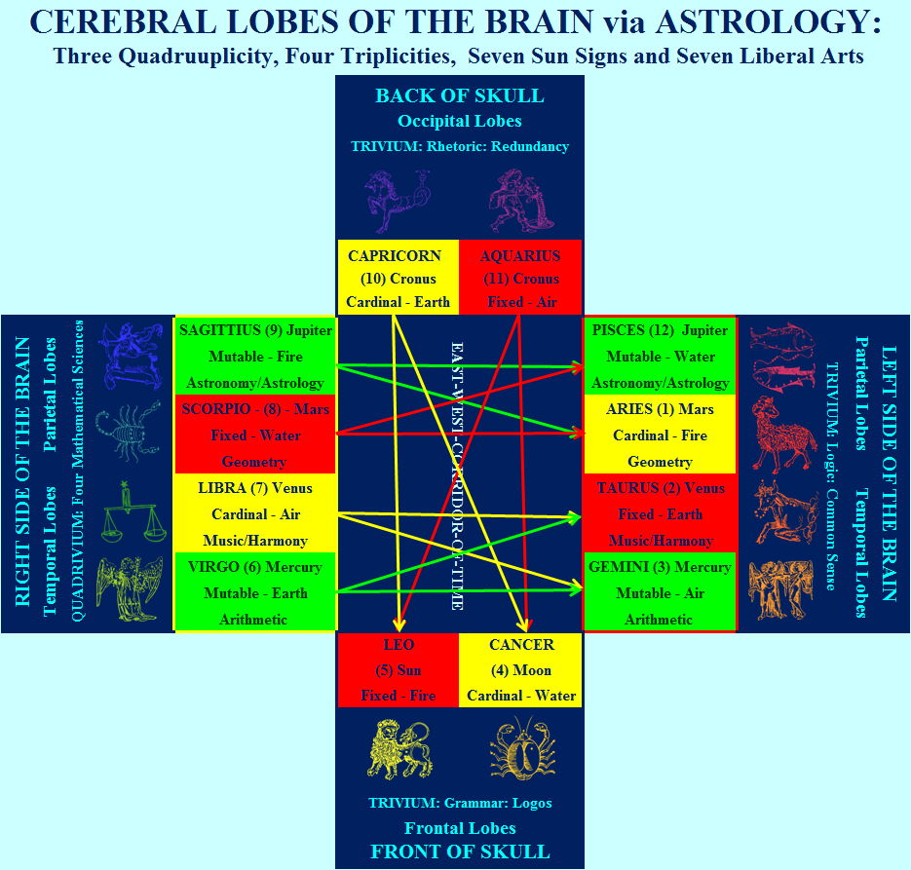 **It is difficult to express to modernity that Christianity per se should not exist in the physical world and it truly doesn’t; though, modernity see what is believes is Christianity. The teachings of Christ are ethereal TRUTHS, which is not visible to the naked eye. That spiritual TRUTH can only be experienced psychically in the Garden of Eden walking with God. Christianity in the world is merely the WORD OF GOD symbolized in symbolism (iconography) and esotericism and all that is just the outer husk (facade) of the TRUE spiritual nature of the teachings of Christ.**

**Notice how the Cardinal (yellow) and the Fixed (red) goes horizontal from the right side of the brain to the left side of the brain and then they go down the east-west-corridor-of-time vertically; thus, creating a CROSS. It is that male (Mars - war) and female (Venus - peace) CROSS that Christ died on. This is why these two have to be mystically married before entering the temple to enter the Holy of Holies: Christ (Horus) consciousness.**

**On the National Mall in Washington DC is the Capitol Building sitting in the center of the PLACE OF THE SKULL, which has two monuments (eyeballs) on 1st Street NW looking down Pennsylvania Avenue (Monument of Peace) and Maryland Avenue (Monument of War: Garfield Monument). The New Testament says there are no male and females in heaven. The fact that the SKULL is facing west, instead of east like the Sphinx on the Giza Plateau, is an explicit indication that it is meant to be seen as a slanted perspective. Or the two-eyeballs could be suggesting not only having peripheral vision; but, eyes in back of the head indicating 360º vision.**

**Leo (ego-consciousness): Fixed Quadruplicity (red) is the right frontal lobe and it controls the left side of the brain and this is why the left side of the brain’s border is in red; whereas, Cancer (unconscious mind): Cardinal Quadruplicity (yellow) is the left frontal lobe and it controls the right side of the brain and this is why the left side of the brain’s border is in yellow.**

**By the way modernity’s researchers are saying that the left and right cerebral lobes interact with each other as if the right side of the brain’s cerebral lobes would take information from the left side of the brain’s cerebral lobes. The right side of the brain transubstantiates it data over to the left side of the brain’s cerebral lobe. It would be impossible for the left side of the brain’s cerebral lobes to transmit data to the right side of the brain’s cerebral lobes. It’s obvious, at least to me, that those researchers are misinterpreting the data they are gathering. The whole psychic process pivots upon the pineal gland, which acts as a translator of the data coming from either side of the divide.**

**An analogy of this process would be that the right side of the brain tells the left side of the brain what to do. The left side of the brain determines whether to pay attention to it or not or does as it pleases. That decision that the left side of the brain made is transmitted to the right side of the brain via the pineal gland and this will continuously take place nanosecond by nanosecond. The unconscious mind is always advising ego-consciousness and ego-consciousness can never tell the unconscious mind what it wants to dream about. Throughout the day 24/7 the unconscious mind advises ego-consciousness and for the most part the unconscious mind is summarily dismissed.**

**The crisscrossing lines in the above image pair off the zodiacal signs governed by a Sun Sign and the second arrow points to a Triplicity that it is associated with. The twelve zodiacal signs are paired off into six set of two and then each sign is again mated via the Sun Signs. In additional Mercury and Venus symbolize the ARCHETYPAL (archaic knowledge), Mars and Jupiter symbolize the COSMIC (Omniscience) and Saturn, Sun and Moon symbolize the EXISTENTIAL (temporary knowledge living in the NOW): i.e. the Trinitarian Paradigm.**

**Conceptually it can be envisage that the Seven Sun Signs and the Seven Liberal Arts are symbols expressing the same spiritual concepts that are working in concord with each other to convey the symbolic meanings of the dynamic structure of the cerebral lobes of the brain. If the initiate can conceptualize that the Sun Signs governing the zodiacal signs on the right side of the brain: Sagittarius, Scorpio, Libra and Virgo transubstantiate over to their zodiacal mates via Jupiter/Zeus, Mars, Venus and Mercury on the left side of the brain it then can easily be understood how the Quadrivium’s four mathematical sciences are transubstantiated over from the right side of the brain to the left side of the brain to be psychically and logically evaluated via Common Sense: Reason and Logic by the initiates raison d’etre to be manifested into the material world; however, LOGIC: Common Sense: Reason and Logic from an individual’s raison d’etre does not mean it is TRUTH per se unless of course the psyche is revitalized by the Initiatic Visionary Experience.**

**LOGIC: Common Sense: Reason and Logic is based solely upon the biases, prejudices and preconceived notions that enamor the psyche of the individual. The Quadrivium: mathematical married via what is known as Horus (Christ, Krishna, Buddha and Tao consciousness). Those two giant T-Shape-stone pillars are analogous to Hathor’s headdress, which has the sun disc between the horns of a cow. This is why the goddess Hathor is assign to the Khafre Pyramid on the Giza Plateau. What Hathor is doing is releasing the Sun down the east-west-corridor-of-time and; yes, Hathor can symbolize representing the total eclipse of the sun; however, for the most part she is releasing it.**

**Hathor’s headdress symbolizes Christ consciousness; because, that headdress symbolizes the pineal gland; however, the pineal gland may not allow the sun: i.e. ego-consciousness to receive the spiritual rays from the spiritual forces from creation. It is through the pineal gland whether it spirituality is blocked off or not is how the pineal gland receives it data from the left side of the brain’s cerebral lobes.**

**This is most likely the reason that the COSMIC Hebraic letters that create the word CHRIST in the first word of Genesis are placed in a skip-pattern sequence intermittently being blocked by ARCHETYPAL and/or EXISTENTIAL Hebraic letters.**

**This last can be envisaged in the first letter of Genesis: BETH בּ and the first hidden letter: PEI פ of Genesis that inundates and surrounds BETH בּ in the white area of the page. PEI פ is a letter that is there; however, its rarely ever envisaged. PEI פ has a Gematria value of eighty-one (81 - 9²) called the Kamea of the Moon and when cubed it totals to seven-hundred and twenty-nine (729), which is 9³ cubed. This figure 7.29 is the exactly mileage that the Potomac River takes up in the Washington DC’s ten mile square that separates Maryland and Virginia. Washington DC mystical name is the Virgin Mary; however, Virginia’s land was returned; thus, indicating the virginity of Democracy no longer exists.**

**I mentioned above that the Kamea of the Sun is six squared (6²) and when cubed it has 216-cells. The number 216-symbolizes the spiritual sun and when released from the Kamea of the Moon cubed: 729 the remainder is 513, which exudes the transposition of the number 153 that represent the Vesica Piscis. When these two: ego-consciousness and the unconscious mind mirror-image each other Christ (Horus, Buddha, Krishna, Tao, etc.) consciousness is animated in the psyche. These mathematical alignments and symbolic patterns are not coincidental. This is the manner the ancient sages conveyed their understanding of the WORD OF GOD.**

**ROBERT SCHOCH:**

**His Theory about the Sun**

**I don’t believe Robert Schoch knows that the reality of the equinoctial cycle in the Milky Way Galaxy is the same cyclic process that takes place in the cerebral lobes of the brain in what Carl G. Jung would call the Collective Unconscious, which I call the SHECHINAH’S (Divine Presence) matrix.**

**What I mean by this is that ‘collective humanity’ will not envisage vast changes in their individual psyche; because, their psyches collectively mirror-image the galaxy that they collectively project out onto the blank abyss: outer world; however, on an individual level when an initiate is gifted with an Initiatic Visionary Experience: i.e. enlightened by the spiritual forces of creation (God) the whole psychic process will speed up and eradicated the initiates biases, prejudices and preconceived notions, which can be interpreted symbolically as the ICE-AGE.**

**Robert Schoch theories about the sun going very erratic and volatile around 12,900 brought my attention to the gifted initiate’s psychic interface between the equinoctial cycle and the cerebral lobes of the brain. I believe that the ancient also saw this psychic interface; because, the Sphinx hails back to about 12,920 years ago or half the equinoctial cycle and the Giza Plateau’s Pyramid Complex hails back to about the beginning of the Age of Gemini c. 8640-years. Now half an equinoctial cycle later Robert Schoch theory is saying the sun in the twenty-first century is being erratic and volatile like it was about 12,900-years ago when it melted the ice-age. Andrew Collins’ idea that a comet hitting the earth destroyed the ice age does not make any sense since there is no meteor impact craters 12-13 thousand years old that validate such a theory. Yes, the earth has meteor impact craters; but, they are hundreds of millions of years old.**

**The right side of the brain’s cerebral lobes that reflects Sagittarius, Scorpio, Libra and Virgo symbolize the unconscious mind: i.e. Moon, which I believe symbolizes the total eclipse of the Sun: ego-consciousness, which creates the ICE-AGE.**

**The reason that I believe this is; because, not only was the Sphinx built to reflect the Age of Leo, which begun about 12,920 years; but, also Gobekli Tepe was built in that era. Gobekli Tepe was obviously built to mirror-image the psychic paradigm emitted from the cerebral lobes of the brain. Then about 10,800 years ago in the equinoctial era of Cancer Gobekli Tepe is buried, which is precisely what a crab does with her offspring on the shores of the ocean.**

**Archeologists, Egyptologists and researchers have found vast underground caverns and cities under the lands of Egypt and in many areas around the world, which obviously hails back thousands of years possibly to be the residence of those living in the ICE-AGE.**

**IN CONCLUSION**

**The fact that the New Testament is dated as beginning at the dawn of the Pisces’ equinoctial age and the Old Testament clocks off the equinoctial ages of Taurus, Aries and Gemini it would be difficult for modern religious and/or academic scholars to argue against the ancient sages knowing of the zodiacal cycle’s equinoctial age.**

**What I, personally, am more intrigued about is the fact that the ancient sages in Western Civilization did not stop their religious esoteric teachings via literature, artworks and monuments after the canonized scriptures were hermetically sealed. Directly, from the year of the mythos declaring the death of Christ the ancient sages continue working their esoteric commitment to Western Civilization.**

**I gave incontrovertible evidence of this above when I discussed the beginning of the USA Revolutionary War commencing in 1776; two-hundred and sixteen (216) years after Queen Elisabeth 1 of England tyrannically ousted the Roman Catholic Church from England. I have even provided data showing that during the Civil War esotericism was incorporated into the historical mythoi of the USA’s culture and after the twenty-first (21st) century began Freemasonry is still working esotericism into the landscape of the National Mall.**

**Thus, the fact that Freemasonry is working its esoteric knowledge into the United States of America’s landscape provides incontrovertible evidence that esotericism is a worldwide endeavor.**

**It is incontrovertible evidence that esotericism has never been completely lost to humanity; though, in the minds of the uninitiated it is completely lost; for the reason that, the uninitiate knows absolutely nothing about its existence whatsoever.**

**How do you tell someone that they are completely blind when the outer world is right there in front of them? That is the point; there is no way of explaining esotericism to the uninitiated; for the reason that, their individual biases, prejudices and preconceived notions makes them all knowledgeable.**

1. **The Orion Mystery: Unlocking the Secret Mysteries of the Pyramids (published 1994)** [**https://www.amazon.com/Orion-Mystery-Unlocking-Secrets-Pyramids/dp/0517884542/ref=sr_1_1?s=books&ie=UTF8&qid=1492935300&sr=1-1&keywords=the+orion+mystery**](https://www.amazon.com/Orion-Mystery-Unlocking-Secrets-Pyramids/dp/0517884542/ref=sr_1_1?s=books&ie=UTF8&qid=1492935300&sr=1-1&keywords=the+orion+mystery)
2. **The Cygnus Mystery: Unlocking the Ancient Secret of Life's Origins in the Cosmos (published January 1, 1999)** [**https://www.amazon.com/Cygnus-Mystery-Unlocking-Ancient-Origins/dp/1906787557/ref=sr_1_1?s=books&ie=UTF8&qid=1492935505&sr=1-1&keywords=the+Cygnus+mystery**](https://www.amazon.com/Cygnus-Mystery-Unlocking-Ancient-Origins/dp/1906787557/ref=sr_1_1?s=books&ie=UTF8&qid=1492935505&sr=1-1&keywords=the+Cygnus+mystery)
3. **Cygnus the Swan is flying west**, https://www.jacksonville.com/lifestyle/20190913/looking-up-cygnus-swan-is-flying-west
4. **Beyond the Orion Correlation (April 5, 2017), published by Den of Lore** [**https://www.youtube.com/watch?v=Mck0DVtxgAA&t=20s**](https://www.youtube.com/watch?v=Mck0DVtxgAA&t=20s)
5. **STAR TREX VOYAGE: Season 6: Episode 26: UNIMATRIX ZERO (Part 1)** [**https://www.amazon.com/Pathfinder/dp/B005HEVI82/ref=sr_1_1?ie=UTF8&qid=1493298887&sr=8-1&keywords=star+trek+voyager+season+6**](https://www.amazon.com/Pathfinder/dp/B005HEVI82/ref=sr_1_1?ie=UTF8&qid=1493298887&sr=8-1&keywords=star+trek+voyager+season+6)
6. **STAR TREX VOYAGE: Season 7: Episode 1: UNIMATRIX ZERO (Part 2)** [**https://www.amazon.com/gp/video/detail/B016KDQ1NA?ref_=aiv_dp_season_select**](https://www.amazon.com/gp/video/detail/B016KDQ1NA?ref_=aiv_dp_season_select)
7. **THE COMPLETE MATRIX TRILOGY:** [**https://www.amazon.com/Complete-Trilogy-Reloaded-Revolutions-Blu-ray/dp/B001CEE1YE/ref=sr_1_1?ie=UTF8&qid=1493299103&sr=8-1-spons&keywords=matrix+trilogy&psc=1**](https://www.amazon.com/Complete-Trilogy-Reloaded-Revolutions-Blu-ray/dp/B001CEE1YE/ref=sr_1_1?ie=UTF8&qid=1493299103&sr=8-1-spons&keywords=matrix+trilogy&psc=1)
8. **EZEKIEL’S MERKABAH IN CHARTRES CATHEDRAL:** [**https://www.slideshare.net/williamjohnmeegan/ezekiels-merkabah-in-chartres-cathedral**](https://www.slideshare.net/williamjohnmeegan/ezekiels-merkabah-in-chartres-cathedral)
9. **GOD AMBIANCE:** [**https://www.amazon.com/Gods-Ambiance-Revealed-Matrix-Wisdom-ebook/dp/B01MFBEJ0D/ref=cm_rdp_product_img**](https://www.amazon.com/Gods-Ambiance-Revealed-Matrix-Wisdom-ebook/dp/B01MFBEJ0D/ref=cm_rdp_product_img)
10. **HATOR: Queen of Heaven:** [**http://www.orderwhitemoon.org/goddess/Hathor/Hathor.html**](http://www.orderwhitemoon.org/goddess/Hathor/Hathor.html)
11. **THE LOST CAVES OF GIZA (32:20 minutes into the film. The image of the Pythagorean Triangle is also created by Rodney’s Hale):** [**https://www.amazon.com/Lost-Caves-Giza-Collin-Andrews/dp/B01MQMQ4JW/ref=sr_1_1?s=movies-tv&ie=UTF8&qid=1493459029&sr=1-1&keywords=giza+cave**](https://www.amazon.com/Lost-Caves-Giza-Collin-Andrews/dp/B01MQMQ4JW/ref=sr_1_1?s=movies-tv&ie=UTF8&qid=1493459029&sr=1-1&keywords=giza+cave)
12. **HEAVEN’S MIRROR: Quest for the Lost Civilization:** [**https://www.amazon.com/Heavens-Mirror-Quest-Lost-Civilization/dp/0609804774/ref=sr_1_1?ie=UTF8&qid=1493571602&sr=8-1&keywords=heaven%27s+mirror+graham+hancock**](https://www.amazon.com/Heavens-Mirror-Quest-Lost-Civilization/dp/0609804774/ref=sr_1_1?ie=UTF8&qid=1493571602&sr=8-1&keywords=heaven%27s+mirror+graham+hancock)
13. **GEOMETRY OF THE GREAT PYRAMID:** [**https://grahamhancock.com/kollerstromn2/**](https://grahamhancock.com/kollerstromn2/)
14. **The reader should read this paper: THE ORIGIN OF THE ANCIENT HEBREW ALPHABET:** [**https://www.slideshare.net/williamjohnmeegan/the-origin-of-the-hebraic-alphabet**](https://www.slideshare.net/williamjohnmeegan/the-origin-of-the-hebraic-alphabet)
15. **EZEKIEL’S MERKABAH IN CHARTRES CATHEDRAL:** [**https://www.slideshare.net/williamjohnmeegan/ezekiels-merkabah-in-chartres-cathedral**](https://www.slideshare.net/williamjohnmeegan/ezekiels-merkabah-in-chartres-cathedral)
16. **THE SISTINE CHAPEL: A STUDY IN CELESTIAL CARTOGRAPHY:** [**https://www.amazon.com/Sistine-Chapel-Celestial-Cartography-Mysteries/dp/1479749486/ref=sr_1_1?ie=UTF8&qid=1493640380&sr=8-1&keywords=THE+SISTINE+CHAPEL%3A+A+STUDY+IN+CELESTIAL+CARTOGRAPHY**](https://www.amazon.com/Sistine-Chapel-Celestial-Cartography-Mysteries/dp/1479749486/ref=sr_1_1?ie=UTF8&qid=1493640380&sr=8-1&keywords=THE+SISTINE+CHAPEL%3A+A+STUDY+IN+CELESTIAL+CARTOGRAPHY) **ALSO**

    **GOD’S AMBIANCE is Revealed in the Matrix of Wisdom:** [**https://www.amazon.com/s/ref=nb_sb_noss?url=search-alias%3Daps&field-keywords=GOD%27S+AMBIANCE**](https://www.amazon.com/s/ref=nb_sb_noss?url=search-alias%3Daps&field-keywords=GOD%27S+AMBIANCE)
17. **Khafre satellite pyramid:** [**https://en.wikipedia.org/wiki/Pyramid_of_Khafre**](https://en.wikipedia.org/wiki/Pyramid_of_Khafre)
18. **Mary Baker Eddy** [**https://en.wikipedia.org/wiki/Mary_Baker_Eddy**](https://en.wikipedia.org/wiki/Mary_Baker_Eddy)
19. **Carl G. Jung** [**https://en.wikipedia.org/wiki/Carl_Jung**](https://en.wikipedia.org/wiki/Carl_Jung)
20. **William Griffith Wilson** [**https://en.wikipedia.org/wiki/Bill_W**](https://en.wikipedia.org/wiki/Bill_W)**.** 
21. **SAINT PETER’S BASILICA: Architecturally Inspire and Designed directly from the Sacred Scriptures** [**https://www.slideshare.net/williamjohnmeegan/saint-peters-basilica-architecturally-inspired-and-designed-directly-from-the-sacred-scriptures**](https://www.slideshare.net/williamjohnmeegan/saint-peters-basilica-architecturally-inspired-and-designed-directly-from-the-sacred-scriptures)